CURRICULUM VITAE
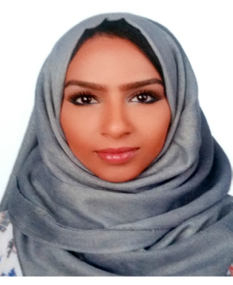
DR.Wala CV No 170208
Whatsapp Mobile: +971504753686 E-mail: gulfjobseeker@gmail.com


CAREER OBJECTIVE

To work in an environment which offers a good opportunity to share my knowledge and Skills with others and participate myself and work towards for a complete satisfaction of the company.

ACADAMIC QUALIFICATIONS

- D.D.S doctor of dental surgery
Ajman University Of Science And Technology, UAE 2006
Complete one year internship 2007-2008
LICENSES CERTIFICATS

      - Holding Dubai Health Authority DHA License (GP Dentist).
- Sudan Medical Council certificate of full
- Certificate of the (American Academy of Continuing Medical Education ) educational activity March,2006 October,2007.

CURRENT JOB

- Working at Hadi Clinic in Dubai.

EXPERIENCE

- One year training experience under consultant supervision by temporary registration in Sudan Medical Council as national service period from 10/2/2009 to 10/2/2010 .
- Full time Medical Officer at the Maxillofacial Surgery Department from 10/2/2010.

DUTIES & RESPONSIBILITY

Cover general dental clinics and department of:
- Restoratives and endodontics.
- Periodontics .
- Prosthodontics.
- Paedodontics.
- Oral&maxillofacial surgery
DUTIES

- Examination .diagnosis and treatment of patients and follow up.
- Restorative and endodontic and conservative treatment.
- Periodontic treatment gums and oral health.
- Prosthodontic and esthetics treatment and replacement .
- Maxillofacial Surgery Department duties:
- Surgical extraction
- Biopsies
- Drainage of abscess
- Fixation of maxillofacial fractures.
- Diagnosis and treatment of oral lesions
- Preparing the patients for refer clinics
- Preparing the patients for major surgeries surgeries under G.A
- Participate as second assistance in major surgeries.
- Follow up the patients inside the ward.
- Participates in presentation of lectures in the department.
- Supervision of the house officers during the work day and in the ER.
- Working in the ER as medical officer to manage the dental and surgical emergencies and trauma patients.

PROFILE HIGHLIGHTS

- Punctual, helpful, considerate and cheerful.
- Keen to learn new skills, learn from past mistakes and face challenges.
- Excellent communication skills.
- Flexible and able to work in a multicultural environment, as part of a team and independently with minimum supervision.
- Disciplined, organized and have a strong sense of responsibility.

PASSPORT DETAILS
- Date of birth : 12/12/1983
- Gender : Female
- Marital Status : Single
- Nationality : Sudanies

LANGUAGES

- Arabic
- English

COMPUTER KNOWLEDGE

M.S. Windows 98
MS. Office 2000
MS. Office XP
Internet Explorer

