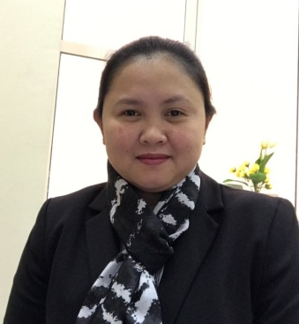
ANN

Abu Dhabi
United Arab Emirates
C/o 971504973598
E-mail: ann.28520@2freemail.com

OBJECTIVE

To become competent in my profession by being an efficient and knowledgeable Accountant and
to achieve satisfaction in my work having done the best that I could. To provide necessary accounting information beneficial for the company’s decision making, therefore growth leading strategies.

WORK EXPERIENCE

FUJAIRAH PLASTIC INDUSTRIES March 2016-PRESENT
Position ACCOUNTS / SALES COORDINATOR
- Making Journal Entry for accounts transaction including stock journals.
- Prepartion of Cash Flow Statement and updating Cash Receivables.
- Processing of supplementary payroll.
- Preparation and monitoring of payables.
- Monitoring Orders from clients and preparation of sales invoices
- Custodian of company petty cash

DEPARTMENT OF EDUCATION March 2015-January 2016
Position Administrative Assistant III
- Monitors school funds, processing of the release of monthly disbursements
- Processing of supplementary payroll.
- Post audit of Cash Advances and checking of liquidation reports
- Monitoring of annual school funds

CLASSIC CHARACTERS INC.(CANADIAN MANUFACTURING) 2006 – 2009, 2010-2015
Position Accounting Department Head
- Prepares financial reports.
- Obtain and maintain general ledger structure
- Develops and monitors company systems and procedures.
- Supervise, train and guide 23 accounting personnel
- Coordinates with all the department managers on issues and concerns

PUREGOLD PRICE CLUB INC. 2009 - 2010
Position Internal Audit Staff
- Audit daily sales transactions, inventory, payroll, cash, petty cash, disbursements, advances, receivables
- Audit all exit documents and receiving procedures (compliance audit)
- Implement and supervise new processes
- Orient and educate all new employees related to procedures, giving refresher courses when needed.

MOSEL VITELIC CORP. INC. (TAIWAN, R.O.C.) 2004 - 2006
Position Technical Assistant
- Operates machinery and monitoring of all loaded wafer IC’s.
- Inspects wafer IC’s based on the standard set by the engineers

ISLAND BEACH TRAVEL INC. 2002 - 2003
Position Accounting Officer
- Prepares financial statements, bank reconciliation and statement of cash flows.
- Prepares payroll and other related reports including government reports
- Monitors all receivables and payables including commission of tour guides.

ACADEMIC QUALIFICATION
TERTIARY
- 1997 – 2002 Polytechnic University of the Philippines - Sta. Mesa, Manila
Bachelor of Science in Accountancy
SECONDARY
- 1993 – 1997 San Pablo Colleges - San Pablo City, Laguna
PRIMARY
- 1987 – 1993 San Isidro Elementary School - San Pablo City, Laguna

ELIGIBILITY

Career Service Professional Eligibility 2003 ( Average grade: 80.81 )

PERSONAL INFORMATION
Date of Birth : June 28, 1980
Age : 37 years old
Place of Birth : San Pablo City, Laguna, Philippines
Citizenship : Filipino
Religion/Beliefs : Born Again Christian
Civil Status : Married

