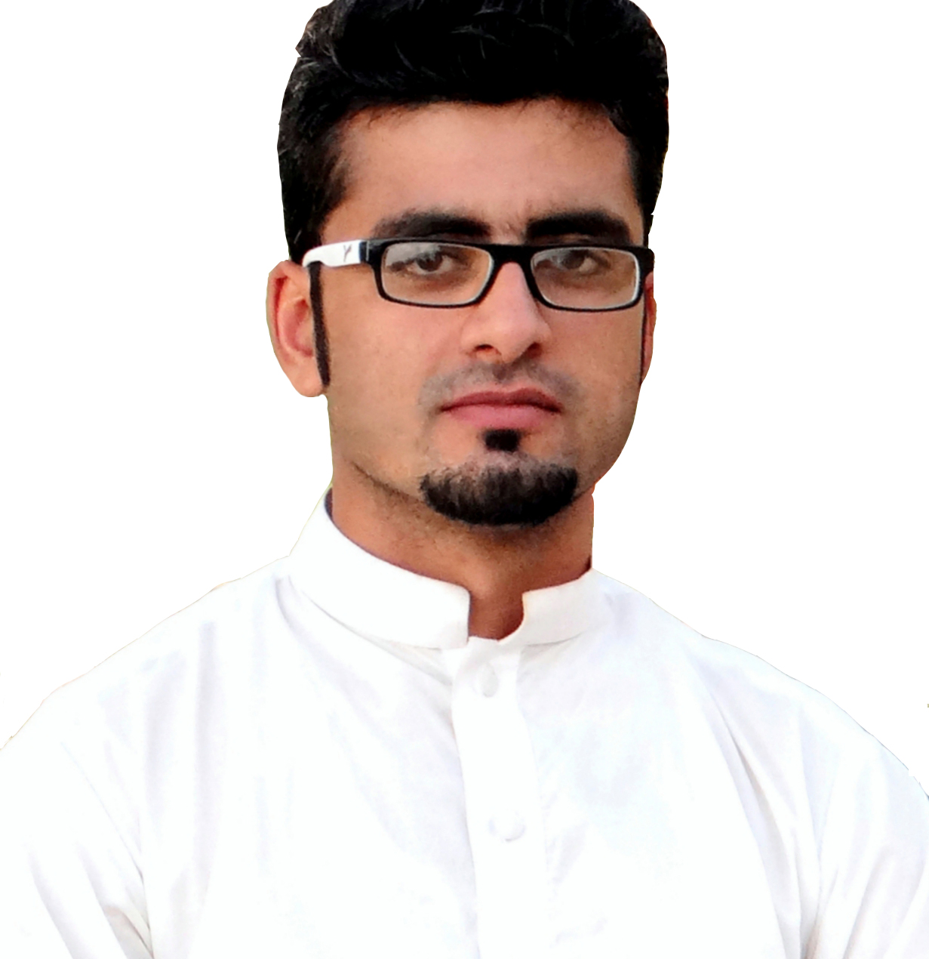
Bilal Khan
Electrical Engineer
Email: Bilalkhanafridi960@gmail.com

Objective

To work in a challenging environment where I can contribute to the growth of the prospective employer by applying my technical knowledge and skills.
Professional Experiences

Electrician in Flying Kraft paper Mills
From August 2015 to Dec 2015
Duration: 5 months
Job Description
I worked there as an Electrician in the Electrical Department of Flying Kraft
Paper Mills and successfully Obtained Experience Certificate by
Completing Five months training there.

Internship in ZTE Pakistan
From June 2014 to Sep 2014
Duration: 4 months
Job Description
I worked as an Internee there and became familiar with Value Added Services. . I successfully completed Four months training there in working on SMSC Node.

Academic Qualification
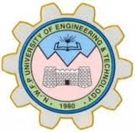

Bachelor in ElectricalEngineering (4 years) ____2015
University Of Engineering and Technology (UET)Peshawar, Pakistan.

Higher Secondary School Certificate (Pre-Engineering) ___2011
GovernmentCollege Peshawar, Pakistan.

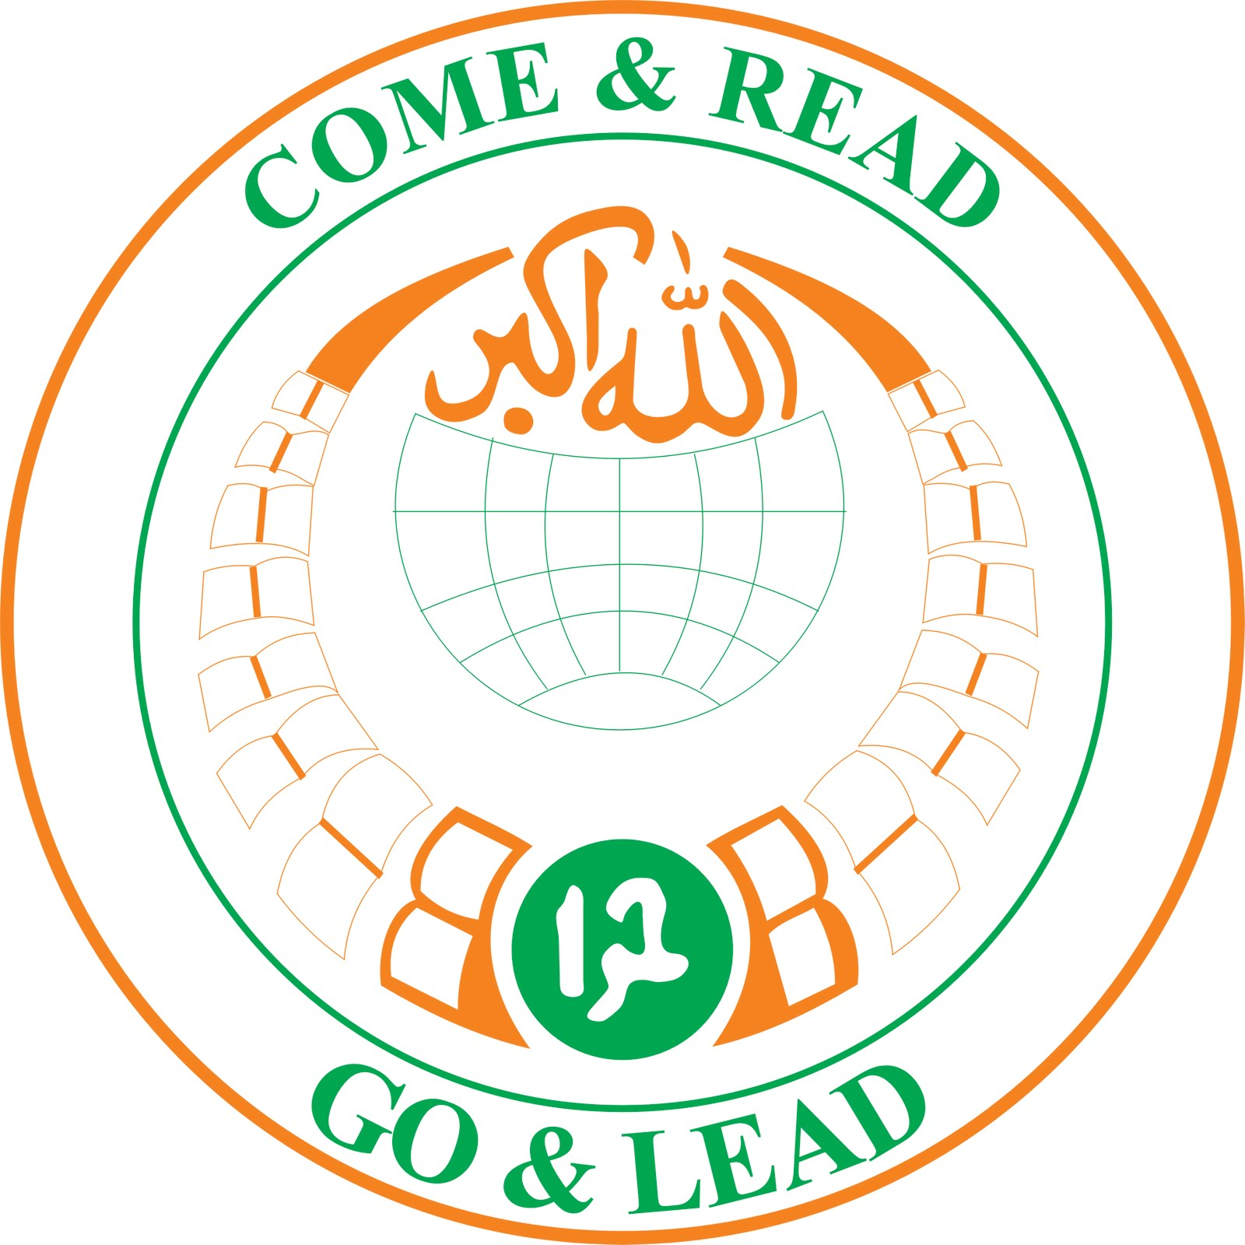
Secondary School Certificate (Science) ___2009
Hira High School Shabqadar Charsadda, Pakistan.

Academic Projects Undertaken

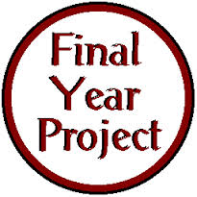
Digital Signature
Duration: One Year

Abstract:

Research based project of Encryptography and Steganography (Data Hiding ).

Touch Sensor
Duration: 4 Months
Abstract:

Electronic project can also be use as a rain sensor ,metal sensor, conductor sensor.

Skills

Technical Skills
- Used Operating Systems:
Windows (XP, 7, 8, Vista)
- Office Automation:
MS Office 2003, 2007, 2010& 2013 (Word, Excel, Access & Power Point)
- Electrical EngineeringSoftware’s:
AutoCAD 2004 , Math lab , Multisim ,Basic C/C++ Programming

- Other Software's:
Photoshop, Ulead , Video Editing , Image Editing , Software/Hardware Installation , Internet Browsing

Communication Skills● English ● Urdu● Pashto
Major Courses Taken

- Optical Fiber  - Communication system  - Introduction to Telecom  - Digital Communication  - Mobile Networking  - Control System | - Data Communication  - Micro controller  - Wireless Communication  - Electronics  - Circuit Theory  - Etc…….

Personal Information

Father Name Yar Muhammad
Date of Birth 25th April, 1994
Marital Status Single
Religion Islam
Present Address Dubai, United Arab Emirates
Visa Status Visit (Valid till 15 May 2016)

References

Will be provided according to demand.

