Curriculum Vitae
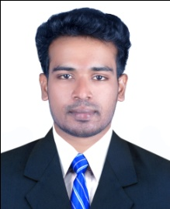 LIVIN  E-mail:  Livin.29471@2freemail.com  Personal Data:  DOB : 20-03-1992  Gender : Male  Nationality : Indian  Marital Status : Single  Hobbies:  - Reading Books  - Watching News  Personal Skills:  - Leadership Skills  - Ability to Create & Maintain Relationships  - Highly Self Motivated  - Work Independent  - Creative, Enthusiastic, Hardworking & Imaginative  - Strong Work Ethics  Languages Known :  - English  - Malayalam  - Tamil  - Hindi | Objective:  To join in a growing organization that offers challenges & opportunity to grow with the company, where goals and objectives are clearly established & tools to reach such goals are provided.  Experience  - Working as QA/QC Mechanical Engineer in Cochin Refinery (BPCL) since January 2015 on contract basis. In piping fabrication/Erection And Structural works  Education:  Course Year of Passing Duration Institute / University  BE – Mechanical 2014 4 years Anna University, Chennai  Plus Two 2010 2 years Board of Higher Secondary, Kerala  SSLC 2008 Central Board of Secondary Examination  Additional Qualification  - QA/QC in Oil & Petrol Refine Engineering from Axionz Institute of Petroleum recognized by American Society for Mechanical Engineers  Technical Skills  - AUTOCAD , MS Office  Declaration:  I hereby declare that the above information is correct to the best of my knowledge.  Date: Place: Dubai LIVIN

