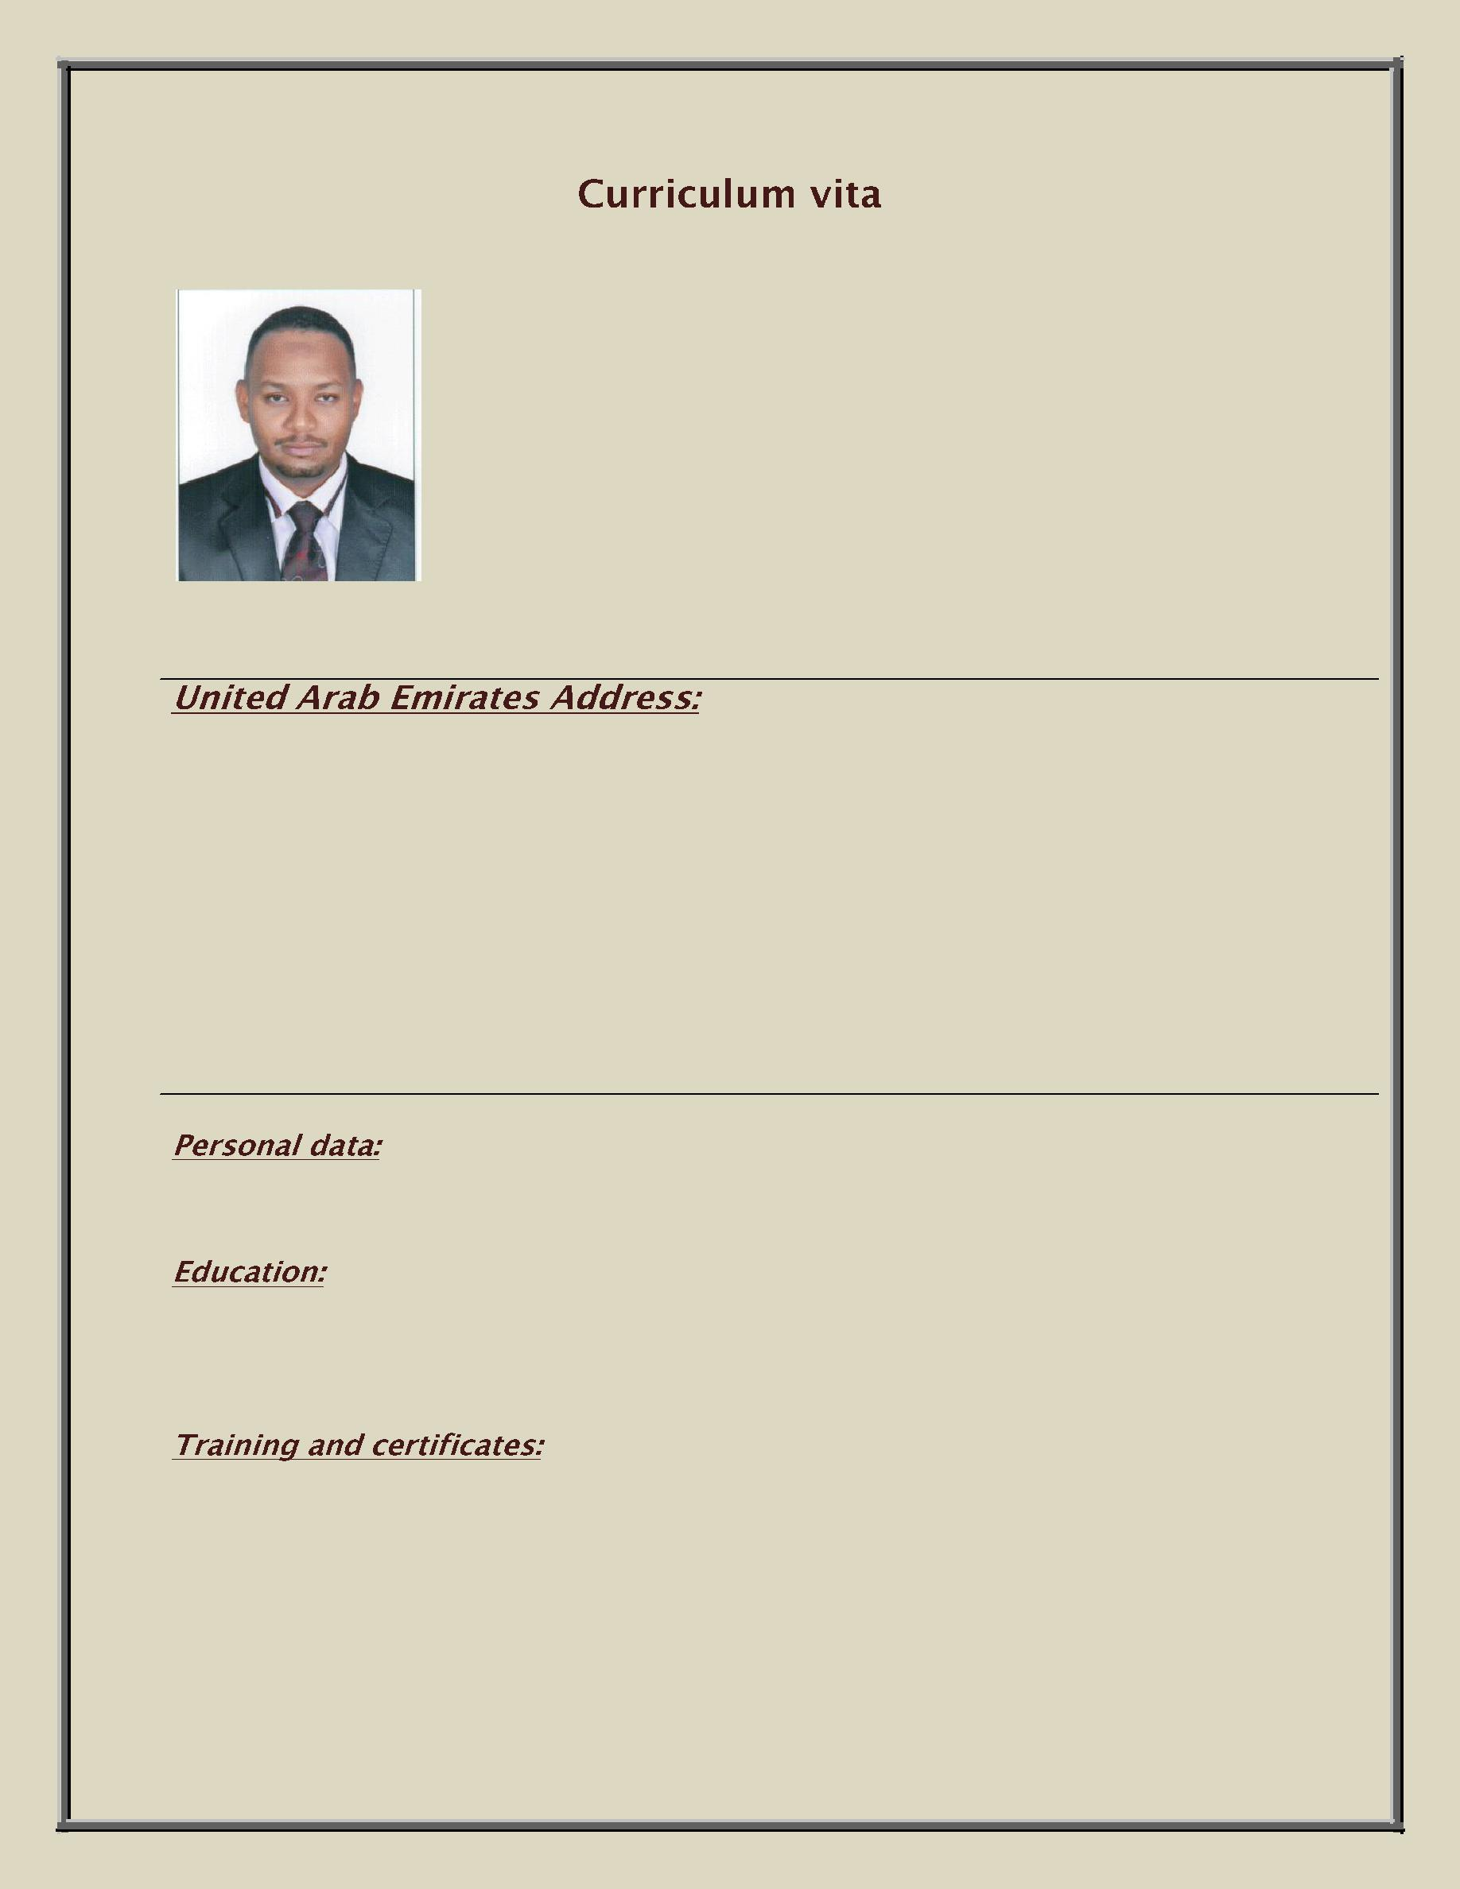

Dr. Mofed

Dubai Alriga Street

E. mail: mofed.29605@2freemail.com

Date and place of birth: 22/07/1978 Sudan

2000-2007: Bachelor of medicine and surgery (M.B.B.S), Khartoum College of medical sciences

- Orientation course for house officer (federal ministry of health)

- Certificate of permanent full registration (Sudan Medical Council 2009).

- Certificate of ministry of health United Arab Emirates license {MOH} march 2013.

- Certificate of Dubai health authority license {DHA} march 2013.

- Certificate of attendance CME (Genetics & molecular Biology) at RAK Hospital.

- BLS certificate 2014

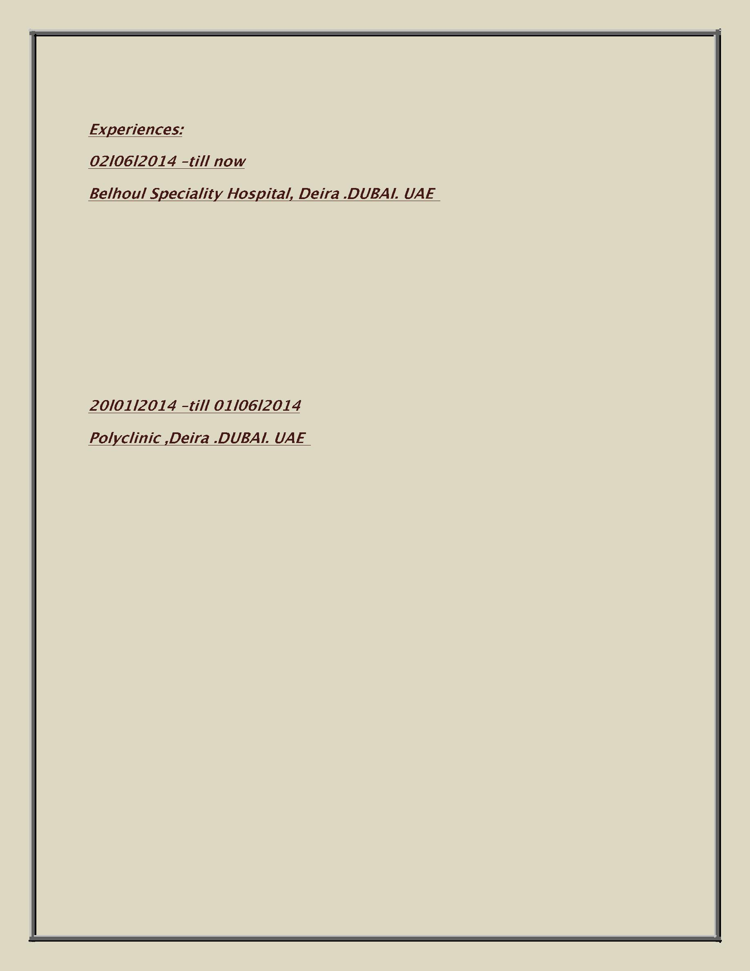

:

- Responsibilities:

- Emergency management and admission of patients at casualty level.

- Taking care of different categories of patients in Medicine, Pediatrics as well as minor surgical procedures.

- Treatment of patients with chronic illness like diabetes, hypertension & hyperlipidemia.

:

- Responsibilities:

- Taking care of different categories of patients in Medicine, Pediatrics as well as minor surgical procedures.

- Stabilization of severely ill patients before transferring to higher facilities.

- Treatment of patients with chronic illness like diabetes, hypertension & hyperlipidemia.

01.07.2009 –29.12.2013: Khartoum north teaching hospital {ER.medical department}

Responsibilities:

- Emergency management and admission of patients at casualty level.

- Daily care and follow-up of patients within the word.

- Preoperative preparation and postoperative management of operated cases.

- Attendance of major and minor rounds conducted by consultants and registrars in the units.

- Out-patient referral clinic

- Assistant in major surgical procedures.

01/12/2010_01/04/2013: Islamic medical association {par time general practitioner}

- Out-patient referral clinic

  - Follow-up of patients with chronic medical condition.

  - Collection, analysis, and presentation of monthly reports.

  - Coordination between stats surveillance officers

17 .04. 2008 – 25. 04. 2009: Internship period, Federal ministry of health as following:

17.04.2008 -17.07.2008 | obst &gynae, bashair teaching hospital
20.07.2008-20.10.2008 | paediatrics, bashair teaching hospital.
23.10.2008-23.01.2009 | Medicine, al ribat teaching hospital
25.01.2009-25.04.2009 | General surgery Khartoum teaching hospital.

- Emergency management and admission of patients at casualty level.

- Daily care and follow-up of patients within the word.

- Preoperative preparation and postoperative management of operated cases.

- Attendance of major and minor rounds conducted by consultants and registrars in the units.
- Out-patient referral clinic

- Assistant in major surgical procedures.

 | Reading | Writing | Speaking
Arabic | Excellent | Excellent | Fluent
English | Excellent | Excellent | Fluent

- Travelling

- Sports

- Computer

Reference:

Available upon request

Notes:

- During my experience I had the honor of working in deferent teaching hospitals and alongside distinguished professors and fellow doctors.

- My objective is to work in challenging environment that accentuates my dedication, work ethics, quick-learning abilities, and strong drive for success.

