CURRICULUM VITAE
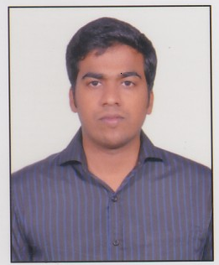Jijo
Jijo.282102@2freemail.com

Professional Experience:

Four year experience in the field of civil engineering related to civil, steel and structural drafting. Major project handled are Hospital, Townships, Group Housing and various Industrial Projects etc.

Employment Record:

Aug. 2010 to Feb. 2011: Worked with Optimization Consultants, Motinagar, Delhi as a Draughtsman in Structural (R.C.C.).

March. 2011 to Aug 2012: Worked with Optimum Design Consultants Pvt. Ltd. Sahibabad, Ghaziabad, U.P as Draughtsman in Structural (R.C.C).
(The company is involved in the civil, steel and structural design of multistory buildings, power plants, Shopping Mall, industrial structures, hospitals, hotels etc.)

Sep. 2012 to Feb 2014: Worked with Structural Engineering Consultants Guragaon as a structural engineer & draughtman(Power structure).

March 2014 to Aug 2014 : Worked with Sheltera Consultants Pvt Ltd. Patel Nagar, Delhi as a structural draughtman.

Areas Specialization:

Drafting & Drafting Co-ordination
Preparation of Architectural, Steel Drawing and Detailing of R.C.C. Drawing, preparation of Structural and drawing for multistoried building, Commercial
building etc. using Auto-Cad 2000, Auto Cad 2004, Auto Cad 2006, Auto Cad 2007 and Auto Cad 2008

Educational Qualification:

S.S.L.C (10th) passed from the Board of Public Examination, Kerala.

12th passed from the Board of Public Examination, Kerala.

Professional Qulification:

- 3 year Diploma in Civil Engineering passed from Board of Technical Education kerala during 2007 to 2010.

- Btech in Civil Engineering from Karnataka State Open University.

Computer Literacy

Diploma in AutoCAD,Diploma in 3ds max

Personal Details:

Date of Birth : 09.02.1990

Nationality : Indian.

Languages known : English, Hindi & Malayalam

Gender : Male

Career Aims

Would like to find a challenging position with in company, where my previous experience can be utilized. I would undertake any additional training beneficial to a new position for the interest of the organization.

