282231@gulfjobseekers.com

Dear Sir/Madam,
It is with great interest that I am forwarding my CV/Resume for your consideration.
My record of academic achievements and professional career history, demonstrates attributes that make me a valuable employee.
My CV/Resume is enclosed to provide you with details of my skills and accomplishments, but I am certain that a personal interview would more fully reveal my desire and ability to contribute to your organization.
Thank you for your time and consideration, and do not hesitate to contact me if you have any questions.
I am looking forward to speak with you soon.
Yours Sincerely,

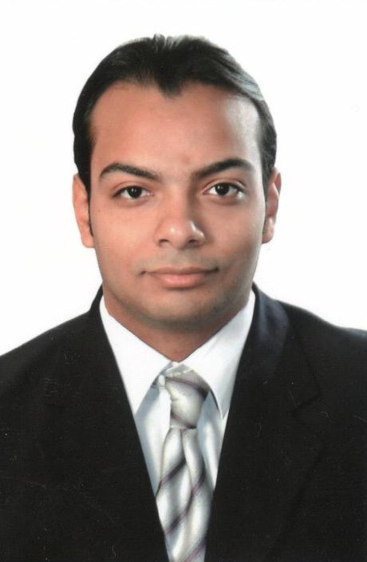
EDUCATION
- MA International Relations, Queen Mary University of London, 2013/15.
- Trainee, Uprising Leadership program, London Feb-July 2015.
- J.M. Module, Euro-Mediterranean studies Program, Cairo University 2011.
- B.Sc. Politics and International Relations, LSE 2008/11.
- B.Sc. Business Administration, Arab Academy for Science and technology (AAST), Alexandria-Egypt, Major: Marketing 2007/11.
- Trainee, Managerial Skills, The Higher Institute for Hotels and Tourism Management (Switzerland) –Hurghada campus, Egypt. 2008
- High School Diploma, Victoria College-Alexandria 2005/07.

WORK EXPERIENCE
- Marketing Ambassador, University of London International programs, Jan 2013-current. --Marketing to UoL International programmes’ events and activities.
-Participant in organizing UoL conferences and projects
-Engage in email correspondence with candidates to provide advice on study based on personal experience.
-Put recommendations for new ideas or corrective action for any deviation then plan of action for implementation.

- Documentary Administrator, InfoFort (Aramex)-Secure Records and Information Management Solutions, Dubai, UAE August 2015/ Feb 2016.
- Working on “Capital City Project” for UAE interior ministry.
-Verify all documents are segregated and classified according to scope.
-Verify all documents are scanned with right attributes, quality orientation and original sequence.
-Verify all documents are indexed correctly and accurately according to scope.
-Report any exceptions or deviations to the project supervisor for corrective actions.
- Taught program Course Representative. Queen Mary, UoL October 2013-14.
-Collect students' views and submit reports to the lecturers in monthly meeting to develop the academic environment and provide students' feedback.
-Cooperate with other courses' representatives and student union to provide support, surveys and develop students' academic life.
- HR officer, A. M. Awad Company-Custom Clearance and Services, Egypt, Sept 2011- August 2013
-Responsible of the company’s human resources and personal management for 256 employees.
-Develop and implement a human resources plan
-Ensure that accurate job descriptions are in place.
-Prepare, develop and implement procedures and policies of staff recruitment
-Writing monthly evaluation report about staff performance
-Provide and organize training sessions, workshops for the staff
-Manage the employees' profiles and database.

OTHER SKILLS
- ICDL 2012: Word, Excel, Access, PowerPoint and Outlook.
- Languages: Arabic, English (fluent), French (Intermediate), Spanish (Basic).
RESPONSIBILITIES AND INTERESTS
- Member, Middle East Public Relations Associations (MEPRA), August 2015-current
- Trainer, WTO Model - Bibliotheca Alexandrina (BA), Sept-Nov 2011. Provide assistance and advice on the academic and personal skills’ training contents to the academic committee team.
- Director, Model of Arab League (BA), 2010. Coaching on communication & political skills and evaluate the delegates through interviews, presentation sessions, workshops & assignments.
- Event Organizer, the 71st Rotary International Conference District 2450 (Egypt, Jordan, Lebanon, Bahrain, UAE, Armenia, Cyprus, Georgia and Sudan), BA, 2007.
- Responsible for registration, preparing conference’s bags, brochures, transportation, hotel Accommodation, publications, banners and nametags for more than 300 attendees.
- Past Secretary/President of Rotaract Club of Alexandria San Stefano, 2007-2008.
-Handle the club's communication with the public, the Rotary club's sponsor, prospective members, Rotary International, and other Rotaract clubs.
-Takes the minutes for all club meetings,
-Maintain list of club members with current contact information and in good standing
-Liaise with Treasurer and the president to determine the club projects’ plans
Club’s projects:
- The Black theatre Project
- Minimally invasive neurosurgery conference, Alexandria
- Alexandria Road Safety project
- “Ezbet Al Malaha” community service project
- In addition to volunteering experience in organizing conferences, models of international organizations, UK general elections 2015 and extra curriculum courses in languages.
REFEREES
Available upon request

