Waqas
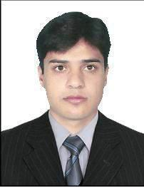

Abu Dhabi, United Arab Emirates

E-mail: waqas.282370@2freemail.com

JOB OBJECTIVE

Seeking a challenging opportunity in an organization which values high standards of performance, & which provides occasions for professional advancement.

PERSONAL INFORMATION

■

■

■

■

■

■

■

■

Name: Waqas

D.O.B: 19-04-1992
C.N.I.C No. 16101-5741773-3
Domicile: Mardan

Marital Status: Unmarried
Nationality: Pakistani

Religion: Islam

EDUCATION

• | Qualification | Division | Year | Board/ University
 | S.S.C | ₂nd | 2008 | B.I.S.E Mardan
• | F.Sc computer science | ₂nd | 2010 | B.I.S.E Mardan
• | D.A.E (diploma associate engineer civil) 1st |  | 2013 | Peshawar Board
PROFESSIONAL QUALIFICATION
• | T.T.B | ₁st | 2008 | N.W.F.P Trade Test Board
• | D.I.T | ₁st | 2008-09 | Peshawar Board
• | AutoCAD (2D + 3D) | ₁st | 2010 | N.W.F.P Trade Test Board
• | Total Station Advance Course 1st |  | 2011 | S.P.I. Swabi

COMPUTER SKILL

- Hardware.

- Installation & Operating System. o Window 98

o Window Me

  - Window XP

  - Window 7

  - Window 8

  - Window 9

  - Window 10.1

  - Ms Dos

- Ms Office
  - Word
- Excel
  - Power Point

  - Excess

  - Out look

- Designing
  - AutoCAD (2D+3D)

  - Survey Side

  - Eagle Point

  - Quick Surf/X-Sections

  - Adobe Photoshop

  - Corel Draw

  - Safe

  - A Plus

  - Etabs

  - CNC Programmers

- Internet
  - Browsing
  - Mailing

  - Searching

- Audio Video
  - Ulead Video Studio

  - Ulead Media Studio

WORK EXPERIENCE

Mar/24/2015- PRESENT EUROFAB ALUMINUM AND GLASS DIVION Abu Dhabi, UAE

Cnc programmers Auto cad and it also

Member of

Projects produced under my responsible

- Ritz Carlton hotel located at abu dhabi behind H.h Sheikh zayed mosque.

( project value of 26000,000 AED), Technal system
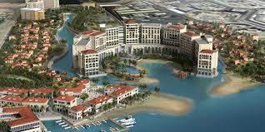

- Reem tower high raised building 25 floors located at abu dhabi Khalifa street,

(project value of 10,000,000 AED), Gulf Extrusion System

- NPC villas compound contained of 129 villas located front of H.h Shiekh

Zayed Mousqe. ( project value of 30,000,000 AED), Technal Syaytem

- Rotana hotel contained 4 buildings, Luxury hotel, (project vaule 45,000000 AED), FB
system
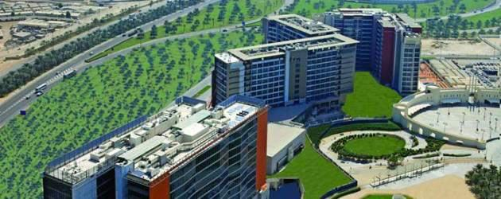

- Cetro barsha hotel at dubai luxury hotel, (project value of 7,500,000 AED) Gulf

extrusion system
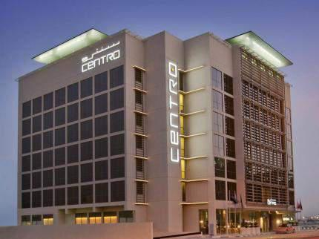

• Bateen project complex of 12 building and 72 villas
(project value of 11,100,000 AED) Technal system
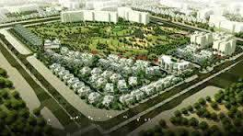

- Four years’ experience in AutoCAD Abdul Wali Khan University Mardan.Pakistan

  - One year experience as an AutoCAD Operator (Jamal Khail Construstion Company (Project AWKUM)

  - Six months experience as an AutoCAD Operator with (Liaqat & Brothers) Project

AWKUM.

  - One year experience as an AutoCAD & QS. with (M/S Ismail Construction Company) Project AWKUM.

  - Four months experience as an AutoCAD, Civili Engineer site work with (ACE Architectural & Town Planning Service (PVT) LTD) Project AWKUM.

  - One year experience as an Civil Engineer with (M/S Sahil Builders) in AWKUM.

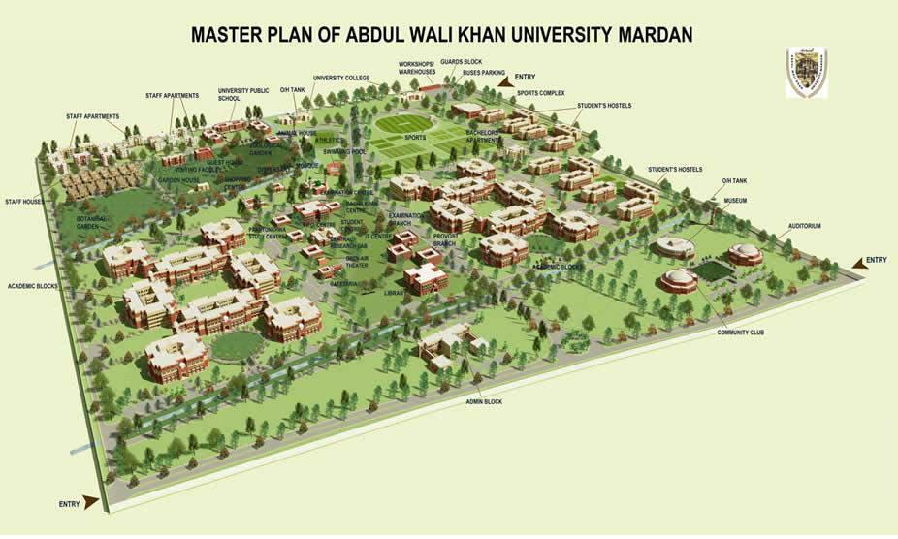

♦

http://www.awkum.edu.pk/

A D D I T I O N A L S K I L L S :

Soft Skills
- Excellent Interpersonal & presentation skills

- Ability to apply academic knowledge to real life situations
- Team player
- Result oriented and Meets deadlines
- Performing well under pressure
- Flexibility to perform various tasks
- Managerial skill
- Operational skill

L a n g u a g e s

•
• | English | Conversational – Advance
• | Urdu | Fluent - Full Knowledge
• | Pashto | Fluent - Full Knowledge

