CURRICULUM VITAE
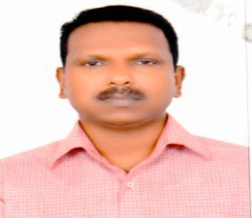
MURALEEDHARAN
Mobile : C/o 0503718643

OBJECTIVES

To be part of professional organization and work in challenging environment which
offers an opportunity to grow develops and contributes to the growth of the organization.

ACCADEMIC QUALIFITION

B.A-.ECONOMICS-PASSED

GULF EXPERIENCE: Since 7 years Working as a Storekeeper

Organization : Al Jaber Carpentry&Decor
Abu dhabi,Mussafah.

WORK EXPERIENCE

16 Years Experience in Carpentry Work in kerala,India.
7 Years Experience in Carpentry storekeeper Work in Al Jaber carpentry&Decor
Presently Working as a Storekeeper in Ali mousa joinery ,sharjah

ACHIEVEMENTS

Achieved Excellent Experience in Carpentry & Décor
Achieved Excellent Communication Skill

LANGUAGES KNOWN

English,Hindi,Malayalam,Tamil and Arabic
Post Applied for : storekeeper Expected Salary : AED 5000+Accomodation
PERSONAL DETAILS
Date of Birth : 06.08.1970
Marital Status : Married
Religion : Hindu
Nationality : Indian

CONTACT INFORMATION

Gmail : muraleedharan.282374@2freemail.com
DECLARATION

Above mentioned all the details are correct and true of my knowledge.

Looking for a placement with an organization where I can perform my skills, knowledge and
experience for a mutually benefiting career. I therefore, assure you my ability to fulfill my duties to the entire satisfaction of my superiors.

Kind Regards,
MURALEEDHARAN

