CURRICULAM VITAE

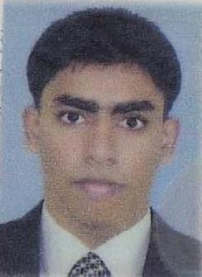
Job Objective:
To got Training a progressive Hospitality organization in India, one which offers a satisfying career and provides for excellent professional and personal growth. Now looking for a new and challenging job position like as Head Waiter, Restaurant Supervisor, Shift Incharge, Catering Supervisor one which will make best use of my existing skills and experience.
Academic Qualification:
2008 – 2012 Bachelor of Hotel Management (BHM)
Purbanchal University (Kantipur International College, Buddhanagar, Kathmandu,Nepal
2006 - 2008 Intermediate (I Com)
Tribhuvan University (Surya Narayan, Satya Narayan Bahumukhi Campus, Siraha
2006 School Leaving Certificate (SLC)
His Ministry Government, Nepal (Chandra Ma. Vi. Siraha
Professional Qualification:
- Extreme Flair Bartending.
(From Kathmandu Flair Bartending Institute, Kathmandu, Nepal

- Banquet Server Trainee in Shankar Hotel 4*, Kathmandu, Nepal.

Professionals Work Experience:
- Worked as Food & Beverage Attendant in Safir Doha Hotel , Qatar ( Doha )

- Worked as Food & Beverage Senior Captain in Tamas Laya Restaurant and Lounge, Kathmandu (Nepal )

- Worked as Food & Beverage Captain in The Junction Restaurant and Bar Milan Chowk, Kathmandu ( Nepal )

- 6 ( Six ) Month Industrial Training in The Peerless Inn, Kolkata, India.

- Food & Beverage Department
- Kitchen Department.
Computer Proficiency
- Diploma in Computer ( Ms Office Package, Internet, Tally, Accounting)

Language Ability
- English, Urdu , Hindi & Nepali

Personal Profile:
- Date of Birth : 02-Feb-1991
- Nationality : Nepalese
- Gender : Male
- Marital Status : Single
- Religion : Islam ( Muslim )
Hobbies:
- Playing Cricket, Singing, Reading Books & News Paper.
Strengths:
- Highly Professional
- Friendly Nature
- Hardworking
- Good knowledge about the MICROS ( POINT OF SALE) SYSTEM

First Name of Application CV No : 1695762
Whatsapp Mobile: +971504753686

