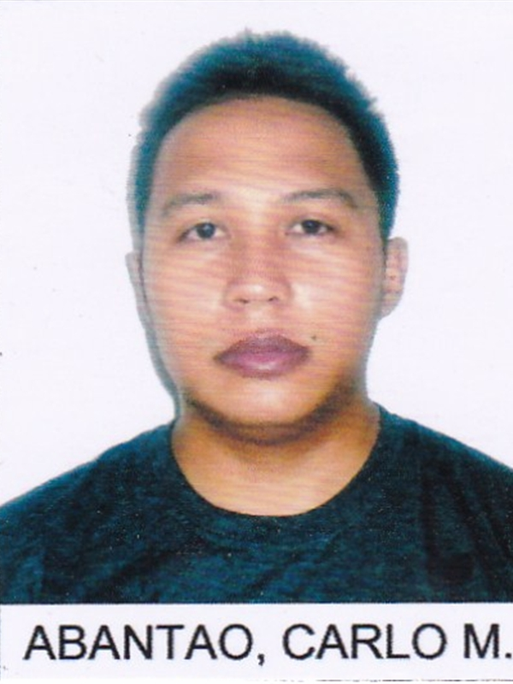
CARLO

JOB OBJECTIVE: Staff Nurse / Homecare Nurse
AVAILABILITY: as soon as possible
EXPECTING SALARAY: 7000 aed and above

- To acquire a job wherein my knowledge and skills in health care could provide efficient and effective support for the health team.

- To expand my experience in health care delivery and to enhance my skills and competencies.

- To work hand-in-hand with the institution and its health team in accordance to their vision, missions and standards with regard to providing health care services.

WORK EXPERIENCES________________________________________________

HOSPITAL/ INSTITUTION : FIL-MABUHAY AGENCY

AREA OF ASSIGNMENT/ POSITION : Private Duty Nurse (Adult Care Section)
DATE OF SERVICE : January 10, 2016 up to present

HOSPITAL/ INSTITUTION : San Juan de Dios Hospital (230 bed capacity)
AREA OF ASSIGNMENT/ POSITION : Private Duty Nurse (Adult Care Section)
DATE OF SERVICE : June 01, 2014 to December 01, 2014

HOSPITAL/ INSTITUTION : San Juan de Dios Hospital (230 bed capacity)
AREA OF ASSIGNMENT/ POSITION : Los Angeles Unit (LAU), Mother and Child Section /
Staff Nurse and Unit Preceptor
DATE OF SERVICE : August 5, 2011 to May 30, 2014

HOSPITAL/ INSTITUTION : San Juan de Dios Hospital (230 bed capacity)
Section /
Staff Nurse
DATE OF SERVICE : December 10, 2007 to August 4, 2011

OTHER POSITION/S HELD:

HOSPITAL/ INSTITUTION : San Juan de Dios Hospital (230 bed capacity)

AREA OF ASSIGNMENT/ POSITION : Infection Control Committee (ICC) Link Nurse
DATE OF SERVICE : February 29, 2008 to August 5, 2011

LICENSURES AND REGISTRATIONS____________________________________

(HAAD PASSER)
Result date: 04 march 2016

Passer of Local Board Examination for Nurses in June 2007

- License Number: 0435602
- Valid until: 07/29/2016

Passport Number: EC4857408

- Placed Issued: Manila, Philippines
- Date of Expiry: August 03, 2020

PERSONAL INFORMATION____________________________________________

- Birth date: July 29, 1986
- Age: 29
- Gender: Male
- Civil Status: Single
- Religion: Roman Catholic
- Citizenship: Filipino
- Language Spoken: English, Filipino
- Educational Attainment: BS in Nursing
- Profession: Registered Nurse
- Total Years/Months of hospital experience: 7 Years and 6 Months
- Total Years/Months of private duty nursing: 1 year and 9 months
- Total Gulf experience: none

PROFILE:

Highly motivated and patient-oriented professional
Fast learner and a dynamic team player
Determined, dedicated and flexible individual
Good oral and written communication skills in both English and Filipino.
Computer literate especially in MS word, Excel and Powerpoint Presentation

SKILLS____________________________________________________________

Proficient with the standard nursing activities, application of the nursing process in carrying out
nursing functions, implementation of the medical and nursing care plans in coordination with the other members of the healthcare team, accurate documentation of treatment, procedures and progress notes, and assistance in the physical management of the unit.
Good oral and written communication skills in both English and Filipino. Computer literate especially
in MS word, Excel and Power Point Presentation. Knowledge in basic life support and standard first aid.
Able to deal with any type of clients, costumers or patients through telephone or personal interaction.

HANDLED: EQUIPMENTS/CONTRAPTIONS
- Mechanical Ventilator - Pulmonary Aide - Defibrillator Machine - Oxygen Regulators
- Electrocardiogram Machine - Infusion Pumps - Suction Machines -Blood Warmer
- Pulse Oximeter - Cardiac Monitor - EKG monitor - Syringe Pump
- Chest Tube Thoracostomy - Jackson Pratt drain - PEG/NGT - BiPAP machine
- Indwelling Foley Catheter - Condom Catheter - Tracheostomy Tube - Endotracheal Tube
- Intrajugular catheter - AV fistula - Glucometer -T-piece Set

PROCEDURES DONE AND ASSISSTED:
- Cutdown - Pleurodesis - Peritoneal Dialysis - Wound care
- Central Venous line insertion- Assisting in Intubation - Tracheostomy Care - Wound debridement
- Blood Transfusion - Paracentesis - Assisting in Extubation - IV insertion
- CTT Monitoring - Thoracentesis - Suctioning - Chemotherapy
- Nasogastric Tube Insertion - Condom Catheter and Indwelling Foley Catheter Insertion
- Osteorized feeding - PEG feeding - Gastric lavage - CPR
-CVP monitoring
SEMINARS AND TRAININGS ATTENDED________________________________

Basic Life Support
BLS for Healthcare Provider Course
Healthforce Training Center Inc. (May 23, 2015)

Advance Cardiac Life Support Training (ACLS)
San Juan de Dios Hospital (November 15-16, 2013)

Seminar on Basic Infection Control
San Juan de Dios Hospital (November 23, 2013)

IVF Refresher Course: Nursing Ethics and Nursing Law Interplay in IV Therapy
San Juan de Dios Hospital (March 31, 2011)

IV Therapy Refresher Course: Client-Centered Approach in IV Chemotherapy
San Juan de Dios Hospital (March 30, 2011)

IV Therapy Refresher Course: Coneventional and Non-Conventional Techniques in IV Therapy
San Juan de Dios (March 29, 2011)

EDUCATIONAL BACKGROUND________________________________________
- San Juan de Dios Education Foundation Inc. (College), Pasay City Manila
Bachelor of Science in Nursing 2007

- Pasay City East High School Pasay City, Metro Manila, Philippines
Secondary Course Completed 2003

- Baclaran Elementary School Central, Baclaran Metro Manila, Philippines
Intermediate Course Completed 1999

Job Seeker First Name / CV No: 1713294
Click to send CV No & get contact details of candidate

