Ahmad

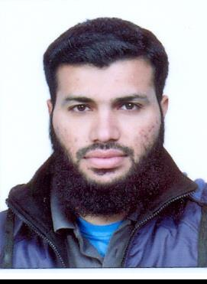
Email: ahmad.285564@2freemail.com

Objective: To address the challenges at a dynamic Organization and add to the personal Growth through learning and organizational growth.

Education____________________________________________________________________________

• | Mechanical Engineering | HITEC University Taxila
• | DAE (Mechanical) | PBTE Lahore
• | Matriculation | FBISE Islamabad

Semester Projects_______________________________________________________________

- Lathe Machine with Animation in Creo Pro 5.0

- Transcendental Equation Pattern on CNC Vertical Milling Machine.

- A Truss Bridge structure verifying laws of Statics.

Final Year Project_____________________________________________________________________

- Design of HVAC System for a Block of Al-Shifa International Hospital Islamabad

Experiences__________________________________________________________________________

Internship |  | 4 Weeks | POF Wah Cantt
HVAC Design |  | 6 Months & | Mezan Engineers
Engineer |  | Still Working
Major Courses________________________________________________________________________
• Heat and Mass Transfer |  |  | Fundamentals of Electrical Engineering
• | Mechanical Vibrations |  | Analogue and Digital systems
• | CAD/CAM |  | Thermodynamics
• | Engineering Mechanics |  | Manufacturing Processes
• | Gas Dynamics |  | Theory Of Machines
• | Mechanics of Materials |  | Design of Machine Elements

Computer Proficiency_________________________________________________________________

- Creo Elements / Pro 5
- ANSYS
- MATLAB

- AutoCAD 2D,3D

Skills________________________________________________________________________________
- Able to effectively manage my time through careful planning and organization of work activities.

- An aptitude for identifying and resolving problems efficiently.
- Excellent communication skills that result in positive interpersonal relationships.

- A track record of meeting deadlines and producing accurate work of a high standard.
- Proven ability to make sound decisions based on valid information.
- The capacity to learn and apply new information quickly and accurately.

Hobbies______________________________________________________________________________

- Reading Researches, columns and News.

- Literature writing.
- In leisure I make strategies to enhance my knowledge and intelligence.

References___________________________________________________________________________

Reference will be furnished if required.

