Ashraf

Mobile - 0554562510.

Email: [ashraf.286314@2freemail.com](mailto:ashraf.286314@2freemail.com)

POST APPLIED FOR MESSENGER

A talented field worker with vast experience in exceeding the expectations of  
clients’ effectively

Objective

To be responsible, dedicated & loyal towards the growth of company improving  
myselffurther.

Work Experiences  
GULF NEWS

Worked as a News Boy from 2006 to 2009.

ADSO FRIEGHT FORWARDERS LLC

Worked as a Messenger from Nov 2011 to June 2014

EMIRATES INTERNATIONAL INSURANCE BROKERS LLC

Worked as a Messenger from Sep 2014 to Nov 2016

Education

Bachelor of Business Administration - Madras University 2000 -2003  
New College - Chennai.

Higher Education - Nehru Boys Higher Secondary School.

Additional Qualification

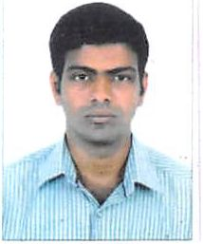

S Having a valid UAE driving license for two wheelers valid till 2026 S Good Road Knowledge of Dubai & Sharjah Road

Additional Information

Gender Marital status

Male

Married

Date of Birth

19.12.1982

Nationality

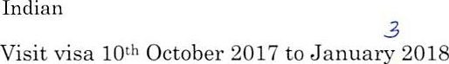

Visa type

/\

Languages Known

English Malayalam Tamil Hindi

Job Profile

S Doing at least 15 visits per day which includes S Meet clients & collecting payments.

S Collecting dishonored cheque from banks

•/ Submitting monthly invoices , relevant documents to the clients S Depositing cash cheque to the concerned accounts S Making payments for company utility bills

I hereby declare that above given information about me are true to my knowledge.

Yours Truly

Ashraf