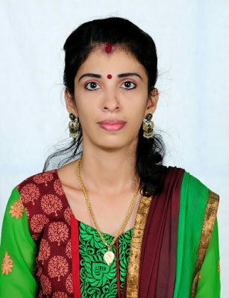

SUNITHA

SUNITHA.286420@2freemail.com

OBJECTIVE:
- Aspiring to become a kindergarten teacher and mould the lives of the next generation of leaders

EDUCATIONAL QUALIFICATION:
- Completed Montessori Teachers Training Course from Malabar Waldorf School, Tirur , Malappuram , Kerala, India in the year 2016.
- Pursuing the Bachelors degree in Commerce from Calicut University ,Kerala, India.
- Completed plus two from Sree Ayyappa Matriculation Higher Secondary School, Perambur, Chennai, India, in the year 2003.
- Completed 10th from sree Ayyappa Matriculation Higher Secondary School, Perambur, Chennai, India, in the year 2001.
ADDITIONAL QUALIFICATION:
- Diploma in Tailoring course from Arun School of Tailoring, Perambur, Chennai, India in the year 2001.

COMPUTER KNOWLEDGE:
- Working knowledge of Word, Excel, Power point and Internet.

PROFESSIONAL EXPERIENCE:
- Worked as a Pre-Primary Teacher in Malabar Waldorf School, Alathiyur, Tirur, Malappuram, Kerala, India from June 2015 to January 2017.
DUTIES AND RESPONSIBILITIES:
- Responsible for handling a class of 35 - 40 students of age group 4-6 years.
- Teaching them basics like shape, color, counting etc.
- Teaching about basics of regular life eating, talking, and behavior.
- Conducting small games in the class.
- Conducting group activities.
- Responsible for their physical and mental development.
- Coordinating with the parents and updating about their child’s development and performance.
- Maintaining the complete records of students.
- Teaching them about natural things, names of animals, flowers, fruits and vegetables.
- Conducting small tests monthly for checking their development and grasping status.
- As per performance giving more attention to weak children.
- Providing creativity and imaginative, work in arts to open minded and creative students.

ADDITIONAL RESPONSIBIITY:
- Conducting Art and Craft classes for KG1 to 5th std and grading students based on their abilities.
EXTRACURRICULAR ACTIVITIES:
Interested in Dance, Song ,Painting and awarded in different competitions
HOBBIES:
Drawing, Painting, Clay modeling, Paper craft, Music, Dance.

PERSONAL DATA:
Nationality : Indian
Date of birth : 28 - 06 - 1984
status : On residence visa under husband’s sponsorship
Sex : Female
Marital status : Married
Languages known : English, Malayalam, Tamil

DECLARATIONS:
I hereby declare that the information stated above is true to the best of my knowledge and belief.

