ABDULLAH  Email: Abdullah.287055@2freemail.com | 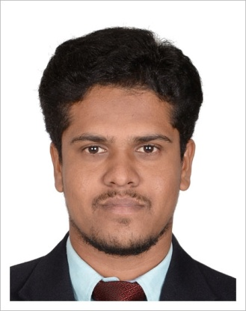

OBJECTIVE
To acquire a challenging and an interesting career in a company to part my knowledge and be a valuable asset to a company by utilizing my Operation and maintenance skills and expertise toward on opportunity with professional growth.

ACADEMIC QUALIFICATION
- Completed D.E.E.E in April 2011
MIET Polytechnic College, Trichy.
- Completed S.S.L.C State board in April 2008
Govt. Hr. Sec. School, Muthupet

TECHNICAL SKILLS
- MS Office Package
- Hardware and Networking
- Windows 8 / 7 / Vista / XP

WORK EXPERIENCE
- Worked as O&M Electrical Foreman in KCP Engineers Pvt. Ltd., Chennai from August 2014 to May 2016.
- Worked as O&M Electrical Technician in AAKVA Technical Services, Chennai from January 2013 to July 2014.
- Worked as O&M Electrical Technician in Enercon India Ltd., Chennai from May 2011 to December 2012

JOB PROFILE
- Operation and Maintenance of Switchgear panels, Transformers, ACB, VCB, Battery chargers, UPS and generators, Solar Panel and RO (Water Purifier) Plant.

- Operation and maintenance of generator which includes switching on/off, checking oil and diesel level and ensuring the filter is free of dust.
- EB, solar panel, on off oil checking diesel checking, coolant checking, checking filter for dust.
- Performed preventive and corrective maintenance on and operated electrical and auxiliary systems resulting in optimal readiness and performance.
- Worked with LV 3-phase system using ohmmeters, voltmeters and ammeter to ensure compatibility and safety of the system
- Troubleshooting the alarms, trips and any other minor fault conditions in panels.
- Ensuring the proper cleaning and maintenance of major electrical equipment and components.
- Performing Planned Preventive Maintenance work regularly on for all electrical utilities.
- Performing routine check on daily, weekly and monthly basis for the proper maintenance of utilities.
- Ensuring adherence to all applicable safety policies and procedures.

PROJECT INVLOVED:-
- KCP Private Limited, Chennai
Commercial building – 1 Basement + 6 Floors + Roof
- Arihant Towers, Chennai
Residential Building – 1B + 12 Floors + Roof

Key Skills:
- Ability to work in a fast paced environment.
- Hardworking and Flexible

PERSONAL INFORMATION:-
Date of birth : 29.04.1992
Gender : Male
Marital status : Single
Nationality : Indian
Religion : Islam

Language known : Tamil and English
Passion of Interests : Reading books, Playing Cricket

Declaration
I hereby declare that the above furnished information’s are true and correct to the best of my knowledge and belief.

Place: Abu Dhabi, U.A.E
Yours faithfully
(ABDULLAH)

