Priya  Email priya.287389@2freemail.com | 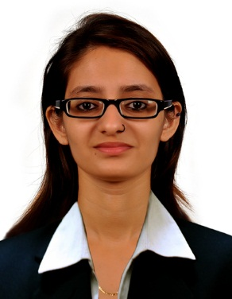

Objective

An opportunity to prove my skills and talent in the most productive way and to secure a position whereby my talent and experience can be used to the maximum extent. I am willing to work as a key player in challenging & creative environment.

Educational Qualifications

Year | Degree | Board / University | Scored
2008 | SSC | Maharashtra State Board | 68.46 %
2010 | HSC | Maharashtra State Board | 81.33 %
2013 | BMS  Business Management Studies | S.K.Somaiya College of Science, Commerce & Arts | 70 %

Academic Projects

Project : M/s Mahendra & Mahendra Automobile Ltd.
: Prepared a project on Mahendra Automobile Ltd.

Entrepreneurship Project : Fashion Boutique
: Developed a feasibility report on setting up a fashion boutique
: Ascertain the profitability of the business over a periexecutive.
: Created the marketing strategy of such a boutique (group project)

Industry Project : Blanket Industry
: Analyzed the industry with respect to demand, supply & competition
: Identify scope for improvement in the marketing strategy by analyzing
the market position of the industry

: Participated at Utkarsh Events

Skills & Interest

- Assistance with first hand computer knowledge - Microsoft Excel, Word, Power Point, Internet Explorer, Sourcing information from various search engines
- Good team working ability, hard work & good communication skills
- To take challenging role in within an organization with growth potential by utilizing my talents and abilities
- Work with professionals and experts in the industry and to utilize my skills to the fullest to continuously add value to the organization
- Meaningful teaching, reading, listening to soft music & painting are few hobbies I posses
- I speak fluent English, Hindi & Marathi
- Knowledge about Bills Receivable, Bills Payable, Bank Reconciliation, Budgeting, Costing, Preparing of Balance Sheet and Profit and Loss statements, Management Accounting, Financial Management.

Work Experience

1. SIS HR Solutions as Customer service executive in Mumbai for 3 months from 1st March 2011 to 31st May 2011

Work Profile

- Handling problems
- Assisting in sales
- Tele sales in inbound and outbound process
- Clerical task

2. Have worked as a Promoter in Nestle and Blackberry Company in Mumbai

3. Salsabeel purification and distribution of drinking water LLC. as sales executive in U.A.E for 1 year from 15th May 2014 to 15th April 2015

Work Profile

- Meeting targets
- Maintaing records and bills
- Maintaing PR relation
- Even done office administration work

4. Currently working with AURA Training Center Fzco as an Assistant Teacher in U.A.E for 1 year from 2nd May 2015

Work Profile

- Conducting classes (Age group 6-15)
- Teaching kids individually and in groups
- Maintaing PR relations with parents
- Maintaing inventory and accounts
- Teaching LEGO Robotics, LEGO More to math and Abacus
- Knowledge of Vedic Math

Visa Status : Employment

Date of Birth : 08 - 03 - 1993

Date of Expiry : 11 - 09 - 2023

Marital Status : Unmarried

I do hereby declare that the above information furnished herewith is correct and true to the best of my knowledge and belief.

Date : Priya

