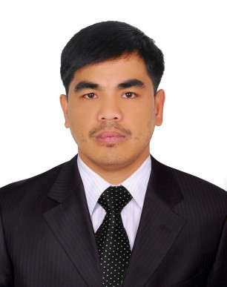
Jun
SALAH ALDIN, DIERA DUBAI
Health and Safety Officer
Objective: To enhance my skills as a Health and Safety Officer by joining forces with a growing establishment seeking qualified applicants.

My last company QA/QC Department appointed me as safety officer for the very big project namedPS-01(thebiggest pumping station in the whole world, site and offices inspection.)

EDUCATION
- NEBOSH IGC: Green World Group Abu Dhabi
- IOSH: Managing safely, institution of Occupational Safety and Health.
- ADOSHEM: BSS Advance Dip in Occupational Safety Health &Environmental Management.
Green World management Consultant & training institute
- Microsoft Word and Excel: Site Power Training Center Dubai
- BSCE: Bachelor of Science in Civil Engineering (University of Baguio)
- Secondary: Lubon National High School

CERTIFICATES:
- For completing all the internal (HSSE) Health Safety Security and Environment Training.
ODEBRECHT INFRASTRUCURE(26 – January – 2016)
- For his significant contribution towards our safety culture and qualimetric results while in the project.ODEBRECHT INFRASTRUCURE ( 25 – January – 2016 )
- For his significant contribution towards our safety culture and qualimetric results.
ODEBRECHT INFRASTRUCURE (14 – April – 2015)
- For his significant contribution towards our safety culture during demolition off beam
ODEBRECHT INFRASTRUCURE (22 – July – 2014)
- In recognition of his active participation during (RMSC) regional Mine Safety Council.
Mines and Geosciences Bureau and Luneta Miners Association Inc. ( 23 Feb. 2011 )
- Basic First Aid and Mine Safety Training – PHILEX MINING CORPORATION ( 24-26 Sept. – 2007)
- Job safety orientation seminar – GA Flores Construction

EMPLOYMENT HISTORY
Appointed safety officer
(Al Wathba, Abu Dhabi)
STEP PS-01 – THE BIGGEST PUMPING STATION IN THE WORLD
RESPONSIBILITIES:
- Conduct & regularly review risk assessment for all areas in the hotel, implement site specific control measures to minimize hazards.
- Implement safe system of work and safety rules and regulation at all time.
- Housekeeping responsibilities in all area (building and working site)
- Always put warning signs and barricade the area if needed.
- Reviewed accidents and incidents to determine cause and implemented plans to prevent reoccurrence.
- Conducted job sites safety and environmental audits which included the completion of documentation of compliance and corrective actions taken.
- Administered the Safety Awareness Program to ensure a safety culture among the work force.
- Monitored site activities for compliance with health and safety guidelines.
- Monitored implementation and enforcement of safety requirements.
- Maintained safety training records and provided safety briefings and appropriate orientation.
- Reviewed health and safety plans.
- Conducted hazard assessments and ensured appropriate control measures and safe work requirements.
- Inspected equipment, structures, and work in progress for compliance with applicable health and safety standards and specifications.
- Recommended corrective actions and measures to improve safety conditions.

RELATED WORK EXPERIENCE
- Appointed safety officer, Documents controller, Miner, (2014 – 2016)
(Al Wathba Abu Dhabi)
STEP PS-01: Shaft excavation for pumping station
- Tunnel safety officer(2011 – 2014)
LUNETA MINERS ASSOCIATION INC. (Benguet, Philippines)
PRODUCTION: Gold Mining Company
- Assistant tunnel Foreman(2009 – 2011)
McConnell DOWELL INC. (Benguet, Philippines)
REHABILITATION: Ambuklao and Binga Dam rehabilitation, no. 1 dam in northern part of Philippines.
SKILLS
- Competent health and safety officer
- Microsoft word and Excel skills
- Can work multi skilled
- Tunnel andBuilding constructionsite expert

PERSONAL INFORMATION
Date of birth:03-june-1980
Gender:male
Height:5”7
Weight: 80 kilos
Nationality: Filipino

I hereby certify that the above information is true and correct to the best of my knowledge.

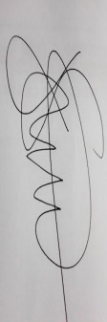

JUN
Jun
CV No: 1727184
Click to send CV No & get contact details of candidate

