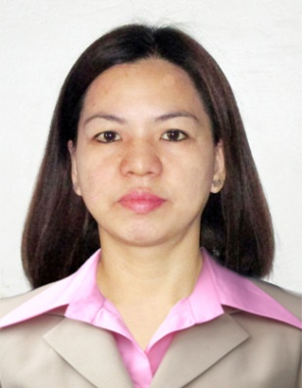
Katherine

CAREER OBJECTIVE

To obtain a challenging and significant job that will require me to apply my verbal-linguistic skills and capabilities and to seek opportunities that will further enhance my potential and acquire experience that will bring out more my competitiveness.

JOB EXPERIENCES

Position : Lady Security Guard
Name of Company : St. Moritz Security Agency
Address : Balanga, Bataan
Inclusive Date : May 18, 2013- May 19, 2015

Position : Massage Therapist
Name of Company : Holy Cross Clinic
Address : Balanga, Bataan
Inclusive Date : July 2010- November 2010

Position : Mechandiser/ Promodiser
Name of Company : Purefoods
Address : Limay, Bataan
Inclusive Date : February 2008- August 2008

Position : Cashier
Name of Company : Jollibee Foods Corporation
Address : Caloocan City
Inclusive Date : October 1999- April 2000

Position : Extensive Tutorial for Elementary Students
Name of Company : Private
Address : Reformista, Limay, Bataan
Inclusive Date : July 2014-March 2015

EDUCATION

Tertiary 2011 to March 2015 Limay Polytechnic College
Limay Bataan
Bachelor of Science in Elementary Education – General Education

ON-THE-JOB TRAINING
Limay Elementary School

Secondary 1995-1999 Navotas National High School
Navotas City, Philippines

Primary 1989-1995 Wawa Elementary School
Navotas City, Philippines

HIGHLIGHTS OF QUALIFICATIONS

- Dedicated and motivated individual with the capacity to consistently achieve objectives.
- Willing to undergo trainings and seminar to improve the quality of my abilities as an individual and for the entire organization.
- Has a full-time commitment to deliver relevant solutions on time in a dynamic, fast-paced environment
- Has good communication and listening skills.
- Computer literate particularly in Word processing and use of internet applications

PERSONAL INFORMATION

Katherine Kath
Name Nickname

Roman Catholic Filipino
Religion Nationality

( Visit Visa Until August 11, 2016 ) August 24, 1981 Single
Passport Number Date of Birth Civil Status

Katherine
CV No: 1727742
Click to send CV No & get contact details of candidate

