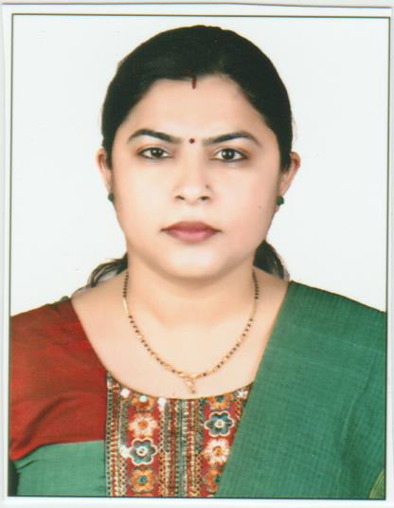

Curriculum Vitae
Narbada
Narbada.288340@2freemail.com

Career Objective:Having enthusiam to work for teaching,seeking a permanent, challenging position in Educational Instituition, which porvides an opportunity to contribute the Instituition and help me to improve my knowledge.

Personal Profile
Date of Birth : 7th June 1980
Sex : Female
Marital Status : Married
Languages Known: English, Hindi and Punjabi

Educational Qualification

Qualification | University/Board | Month-Year
B.A | Osmania University (Hyd) | 2001
M.A (Hindi) | Osmania University (Hyd) | 2003
B.Ed | Dakshin Bharat Hindi Prachar Sabha | 2011

Experience

Vijay Lakshami High School (mehdipatnam):

1.Worked as Hindi teacher for 2 years.
2. Experience teaching to class 6th to 10th.
3.Involved in cultural activities 7

Mount Banjara High School (Banjara hills):

1.Worked as Hindi teacher for 6 years.
2. Experience teaching to class 6th to 10th.

KakatiyaVidyaNiketan High School (NanalNager):

1.Worked as Hindi teacher for 3 years .
2. Experience teaching to class 6th to 10th.

Meridian School (Madhapur)

1. Worked as Hindi teacher for 2 years .
2. Experience teaching to class 4th to 8th .

I hereby declare that the information given herewith is correct to my knowledge and I will responsible for any discrepancy.

