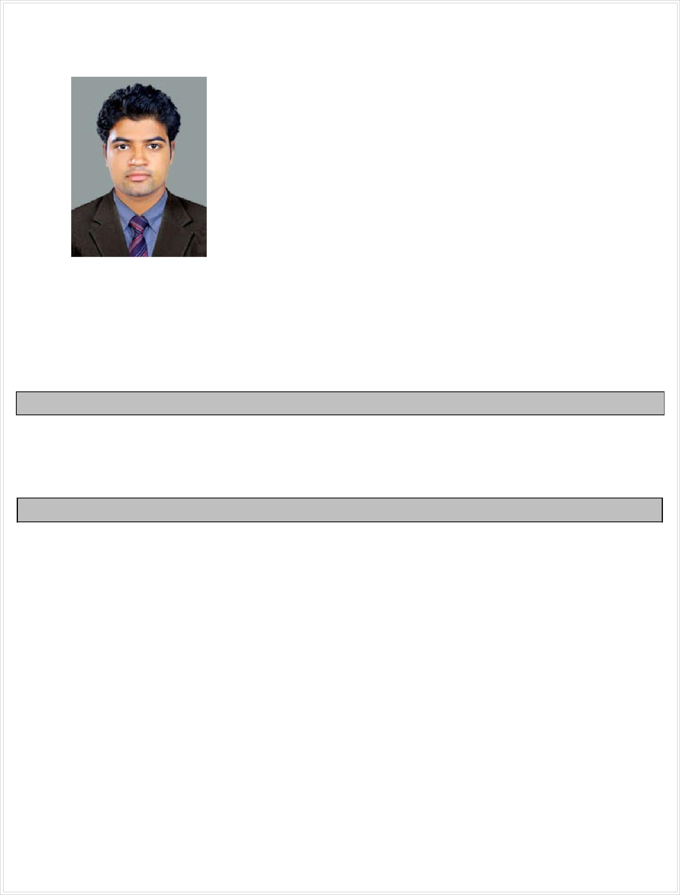

GEORGE
Place :Dubai.
GEORGE.288425@2freemail.com

CAREER OBJECTIVE

To work in a competitive environment, in a challenging position and be an integral part of a growth oriented team with a clear path, wherein I wish to consolidate my intelligence, hard work and dedication and to take up a challenging career.

WORK EXPERIENCE

- Operation executive (Logistics Pvt Ltd,Mumbai) 06-jan-2015 to 29-mar-2016

  - Handling Import and Export documentation.
  - Monitoring Freight movement throughreal-time tracking system.
  - Preparing Freight Certificate,Delivery Order advice,HBL Manifest for filing IGM etc..

  - Submission of relevant documents received from Overseas supplier to CHA.
  - Follow up with CHA for clearance of consignment.
  - Liaison with Carriers and CHA.
  - Resolving customer queries.
  - Negotiating contracts,Transportation and handling costs.
  - Arranging payment of freight on behalf of the client.
  - Performs any other duties as assigned by the supervisor.

- Office Assistant (Sai Saran Services Pvt Ltd,Kochi,Kerala) 12-dec-2013 to 25-sep-2014

  - Control day to day all activities.
  - Update all transactions to system and manual.
  - Maintain good communication with consignee.
  - Verifying purchase and sales invoices.

INTER PERSONAL SKILLS

- Consistently maintain a positive attitude and enjoy helping people.
- Rapport building with another person which draws them into relationship.
- Managing conflict in such a way that the relationship is preserved.
- Patient listener who fully focuses on speakers

ACADEMIC PROFILE

- P.G Diploma in Shipping and Logistics Management: BSS University, Asia Mercantile & Maritime Academy at Cochin, in the year 2013(Marks 80%)

- Graduation in commerce (B.COM): University of Calicut, in the year (2009-2012)(Mark 61%)

- Higher Secondary (PlusTwo (Commerce): Kerala State Syllabus,in the year 2009(Marks 74%)

- Secondary School (SSLC) : Kerala State Syllabus, in the year 2007 (Marks 78%).

TECHNICAL QUALIFICATIONS^{AD}

- Computer Proficiency in Windows, MS Word, Excel and Good Knowledge of Internet & Email.

- Completed a Certified Course in M.S OFFICE.

STRENGTHS

- Confident, Hardworking and Committed with an ability to strive for achieving desired goals.

- Friendly Relation and Honesty.

 |  | PERSONAL DETAILS
Nationality | : Indian
Date of Birth & Age | : 3/10/1991, 25
Sex & Marital Status | : Male, Married
Blood Group | : O +ve
Religion & Caste | : Christian, RC
Languages Known | : English,Malayalam, Hindi and Tamil
Other Activities | : Dancing, Driving Car, Listen to Music.
Current Location |  | : Al jaffilia,Dubai.

DECLARATION
I hereby declare that the above written particulars are true and correct to the best of my knowledge and belief.

