Dinesh

HSE Engineer / Coordinator-Advisor

Seeking assignments in Project Management-Construction in a reputed organisation Industry, preferably in Gulf

SUMMARY
- Over 19 years of experience in HSE Management (Mechanical, MEP, Civil, Oil & Gas)

• Proficient in leading the safety cell to analyse the causes & | Managerial Skills
reduce accidents, increase awareness among the employees
towards maintenance of safe working conditions
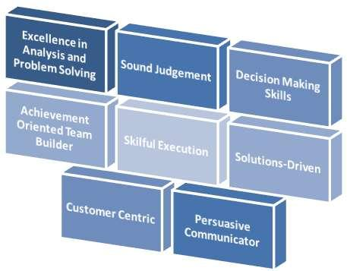
- Competency in developing HSE Management System, conducting compliance audits, advising on HSE requirements, and maintaining sound HSE standards as per management system guidelines

- Adept at developing safety plans, overseeing implementation as well as conducting field safety survey, site safety surveillance & auditing to review the norms for performances

- Extensive knowledge of control safety & health hazards engineering concepts

- Expertise at inspecting and evaluating workplaces for safety hazards and recommending and implementing safe workplace policies and procedures.

- Deft at handling the process of investigation, recording of accident/ safety related incidents and reviewing pre-commissioning & commissioning procedures

- Demonstrated skills in relationship management coupled with excellent analytical and leadership ability

Areas of Expertise
- Implementing the process for reviewing contractor safety performance against applicable laws, regulations, and client requirements

- Developing & enforcing policies, procedures, programs, and standards for client to ensure safety of multiple construction projects
- Reviewing and approving health and safety plans prepared by construction contractors working for the client

- Implementing & maintaining a standard procedure for reporting accidents, incidents and near misses by the contractors in the project
- Implementing & maintaining standard policies and procedures for construction safety

- Implementing metrics for tracking and monitoring as accidents, incidents “near misses,” and lost time events

- Assessing the risks associated with the process and initiate control measures for the same

- Monitoring day to day activities to identify potential hazards and take steps to eliminate those

- Identifying & appraising conditions which could produce accidents and financial losses and evaluates potential extent of injuries resulting from accidents

- Conducting or directing research studies to identify hazards and evaluate loss producing potential of given system, operation or process

- Compiling, analyzing & interpreting statistical data related to accidents, incidents and near misses and present it to the management

- Liaising with the fire department regarding emergency procedures, communications and fire safety education programs

Work Experience
Since Nov’11 Abu Dhabi, UAE as Sr. Health and Safety Officer (Civil & MEP)

Assignments Handled

- Nov’11 to Jul’13 as Sr. Health and Safety Officer/ Environmental Protection Officer (Civil & MEP) (Arzanah Medical Complex Project)

- Since Jul’13 as Sr. Health and Safety Officer (Civil & MEP) (Al Mafraq Hospital Project)

Apr’11 to Oct’11 Emirates Trading Agency (ETA) KAFD, Riyadh, KSA as Project Safety Officer (MEP)

Apr’08 to Mar’11 Voltas (I) Limited-Ferrari World /EPH Project Abu Dhabi, UAE as Sr. Safety Officer (MEP)

May’06 to Mar’08 Gulf Contracting Co. WLL, Qatar Substations Phase VI & VII as Safety Officer (CIVIL & MEP)

May’97 to May’06 Gopinath Engineering Co. (Reliance, BPCL & HPCL Site) as Safety Supervisor / Site Administration (Mechanical Construction)

Certifications
- NEBOSH- IGC

- IOSH – 3 Fold Institute from Abu Dhabi (UAE)

- OSHA – Occupational Safety and Health Administration (TWI Abu Dhabi, UAE)

- IASP-International Association of Safety Professionals - Occupational Safety and Health Advanced Diploma (UAE)

Academic Details

1996 | B.Com. from Calicut University
 | Diploma in Industrial Safety Management from Vihar Industrial Fire and Safety training Centre
 | Diploma in Computer Application and MS Office - Word, Excel & PowerPoint

Trainings Attended
- First Aid Training- Gulf Technical & Safety Training Centre, Abu Dhabi UAE

- Advanced First Aid Training– Saudi Bin Laden Group-KAFD (KSA)

- Authorized Gas Tester training –Euro Gulf Safety Consultant-Mafraq project -UAE

- Safe Use of Work Equipment– (3-Fold Institute Abu Dhabi – Protech Academy UAE)

- Work place Risk Assessment Course – (3-Fold Institute Abu Dhabi -UAE)

- Work Place Health, Safety and Welfare Training (3-Fold Training Center- Protech Academy UAE)
- Confined Space Training- (3-Fold Institute Abu Dhabi -UAE)

- Safe Handling of Hazardous Substances COSHH (3-Fold Training Center- Protech Academy UAE)
- Scaffolding inspector Training – (Al Jamea Trading, UAE)

- Work At Height Training Course – (Voltas, Aldar Besix – UAE, ETA-KSA)

- Fire Fighting and Fire Marshal Training Course(Aldar Besix-Fire Specialist Mr. Larry Algaza UAE)
- HSE Leadership Training (Voltas- UAE)

- Basic Heat and Heat stress Training (Voltas-UAE, ETA -KSA)
- Electrical Safety Training-LOA (Siemens Qatar Substation Phase VI/VII, Voltas, Aldar Besix, UAE)
- Internal Audit Training Course EMS -ISO 14001: 2004 & OHSAS 18001: 2007
- Excavation Safety Training (Sixco-UAE)
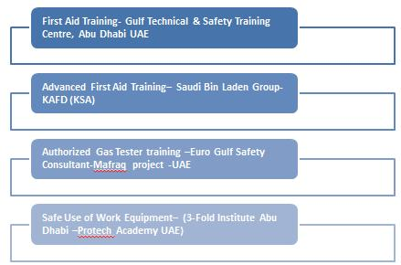

DINESH CV NO: 1732404
Click to send CV No & get contact details of candidate

