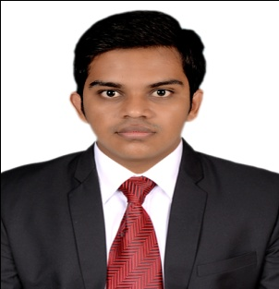

OBJECTIVE:

To work in an organization where I can exhibit my professional skills in making meaningful contribution for the development of the organization and grow along with the organization.

SUMMARY:

- Presently working in Supply chain & Logistics in Import Company, Sharjah.
- Total of two years in Electrical maintenance.
- 3 years intermediate experience in MEP from my Dad’s MEP service Business (India).

EDUCATION & ACCREDITATIONS:
Academics:
- Bachelor of Engineering (Electrical & Electronics), Panimalar Engineering college, Anna University Chennai.

Technical Education:
- C & C++ Programming Languages in Net Masters.

EMPLOYMENT RECORD:
- As Electrical Supervisor from 01 April 2014 to 15 April 2016 in KRAM Electrical Works.

AREA OF EXPERTISE:

- Electrical maintenance.
- Testing of motors.
- Overhauling of LT motors.
- Motor Rewinding.

ACHIEVEMENTS:
- Won 3rd place in Paper presentation in KITEGEN (Production of electricity by changing the method of usage of wind power as prime mover).

ADDITIONAL QUALIFICATION & SKILLS:

  - Computer Skills: Ms Office word, Power point, Ms Excel.
  - MEP experience since I’m the part of dad’s business,

KEY STRENGTH:
- Ability to adapt.
- Self-confident.
- Quick learner.
INPLANT TRAINNING:
- Undergone Implant Training at Neyveli (NLC) In Thermal Power Plant II.
- Undergone Implant Training at Cuddalore (BSNL) Telecom Network.

INTEREST:
- A Long Drive
- MEP
- Wooden Works.

DECLARATION:

The above said information are true to the best of my knowledge, and hope this will be a brief reference for you to give me an opportunity to serve your needs.

