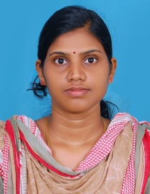
CURRICULAM VITA
DIVYA
DIVYA.289857@2freemail.com

Career Objective

To work for an esteemed organization holding a responsible position enabling career growth and ensuring credible performance within the framework set forward by the company. Seeking a Mid-level Position with an opportunity for professional challenges and intend to build a career with a Leading Corporate with committed and dedicated people. Willing to work as a team player in a challenging and creative Environment.

Work Experience

- Misbahul Huda Arts and science College (Administration officer)-3 year
- Consim info pvt Ltd (Administration Executive)-1 year
- Royal bank of Scotland (compliance officer)-6 months

Educational Qualifications
- MBA (Finance+information System management ), From SRM University, Chennai (2008-10) (CGPA 8.289)
- PG Diploma in Public Relations management 2010 Madurai Kamaraj University (69%)
- BSc (Computer science) from University of Calicut, Kerala in Jun 2007. (74%)
- 12th Kerala State Board in Jun 2004 (61%)
- 10th Kerala State Board in Jun 2002 (75%)

Technical skills
- Experienced in Windows 98, Windows XP, and Windows 8.
- Office Applications : MS-Word, MS- Excel, Ms-PowerPoint, Ms-Outlook and using internet for research & official communication
- Basic knowledge about C, C++, VB, VB.Net, Asp.Net, VF, BASIC, HTML, Having basic knowledge in Tally ERP 9

Personal Skills

- Self-motivated and have high energy level.
- Believe in teamwork, willingness to learn and hard working.
- Dynamic analytical and maintenance skills.
Personal Profile
Marital Status : Married
Nationality : Indian
Date of Birth : 28 Aug 1986
Languages Known : English, Hindi and Malayalam
Current Location : Dubai

