Neethu
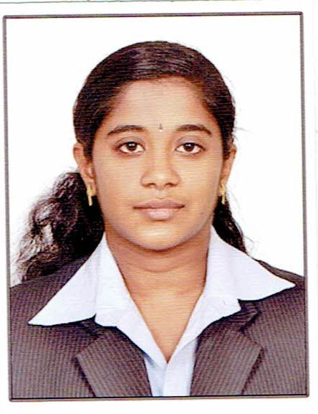
Neethu.290190@2freemail.com

CAREER OBJECTIVE:
To work in an organization where I can acquire new knowledge and sharpen my skills and put my efforts in achieving organization as well as individual goals.
ACADEMIC PROFILE:
DEGREE | COLLEGE/SCHOOL | YEAR OF PASSING | PERCENTAGE
MBA | Sri Krishna College of Technology  ( HUMAN RESOURCE and MARKETING) | 2016 | 86.8 (upto 3rd sem)
B.E | Sri Shakthi Institute of Engineering and Technology | 2014 | 77.2
HSC | Holy Family convent Matriculation higher secondary school | 2009 | 68.4
SSLC | Mani Higher Secondary School | 2007 | 79.4

CO-CURRICULAR ACTIVITIES:
- Certification courses:
- Completed course in Diploma in Computer Science and Engineering with 89% during the year 2009 to 2011.
- Certified of merit in DOTNET PROGRAMMING course.
- Certification on Infosys Campus Connect Programme.
- Android training in Sri Shakthi Institute of Engineering and Technology.

- Workshops:
- Participated in HR conclave on “Managing Talents in VUCA world” which was held at Sri Krishna college Engineering and Technology.
- Software Development and Testing at Sri Shakthi Institute of Engineering and Technology.
- Participated in Business plan events and bridge building a team activity.
- Attended faculty development programme at Sri Shakthi Institute of Engineering and Technology.
- Paper presentation:
- Presented paper on topic “Nano Technology In The Treatment Of Cancer” in SriGuru College.

EXTRA CURRICULAR ACTIVITIES
- Participated in Quiz competition
- Attended one day NALS training in Sri Krishna College of Technology.
- Participated in Essay writing competition
- Participated in management games

AREAS OF INTEREST
- Human Resource Management
- Change Management
- Systems
TECHNICAL SKILLS
- Languages : C, Java.
- DBMS Packages : Oracle 10g, MySQL, MS-Access.
- Web Designing : HTML,VB.NET.
PERSONAL SKILLS:
- Effective Communication
- Teamwork skills
- Positive attitude
- Good learner

MAIN PROJECT IN PG
Title: Effectiveness of Performance Appraisal system
Company Name: Myco Industry, Coimbatore
Duration: 4 Months
Description: Finding the effectiveness of the present system and also identifying whether the employees are satisfied with the current system, the scope for the development of the employees in order to make them to work for the development of the organization.
INTERNSHIP PROJECT IN PG:
Title: Overall study about the working of the industry
Company Name: Roots Industries India Limited
Duration: One Month
Description: Studied about the overall process which includes HR activities, production process and the time management skills and work culture of the organization.

INTERNSHIP PROJECT IN UG:
Title: Location Tracking and plotting users
Description: A project to track the location of the user and also it is used for plotting the location of the user in the map.
Technical specification: Eclipse Android Development Tool and SQL lite.

MAIN PROJECT in UG:
Title: Smart Monetary System
Project Domain: Android
Description: A project to monitor budgets, expenses and savings in a home. Has a database to keep track of these and provide report weekly or monthly or yearly bases. Has a system to set remainder for important occasions.
Technical specification: Eclipse Android Development Tool and SQL lite.
MINI PROJECT:
Title: Credit Card Misled Detection Using Hidden Markov Model
Description: In this project, it is possible to detect the misuse of credit card by other persons and it also helps the user to save their cash from accessing by other persons..
Technical specification: SQL, VB.Net.

Title : Leave Management System
Description: In this project, attendance of each employee in an organization is calculated based on the leaves taken by the employee. Leaves are granted to the employee based on the leave rules.
Technical specification: MS Access, Java.

Declaration
I hereby declare that the above said information is true to the best of my knowledge.

