SULSILA.290243@2freemail.com

PERSONAL SUMMARY
SULSILA
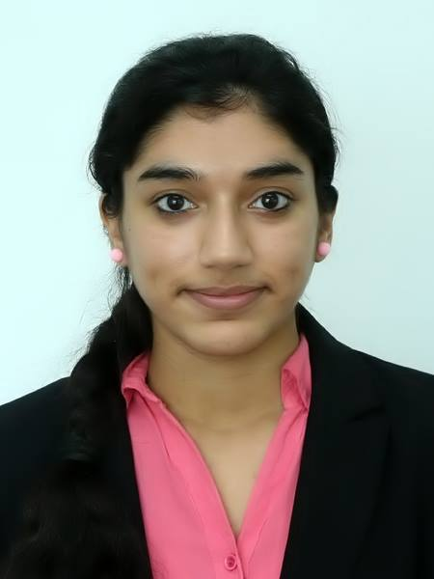
Personal Data:
DOB : 06th-Feb-1994
Marital Status : SINGLE
Nationality : INDIAN
Address : Near Mega Mall, Sharjah
UAE Driving License : Yes

Languages Known:

English, Hindi, Tamil, Malayalam.

An enthusiastic Management Student with the necessary knowledge and determination needed to resolve complex marketing and management issues.I have a proven track record of managing and maintaining Accounts and desktops in preparing Salary sheets, WPS, Payroll and adopt a meticulous approach to ensure the smooth-running of business operation.

Now looking for a new and challenging Administrator position, one which will make best use of my existing skills and experience and also further my development, I enjoy closely following the latest changes in technology and apply this to my duties wherever relevant.

KEY SKILLS

- Active Administration skill.
- Microsoft Exchange Management.
- Configuring balance sheet and presentations.
- Preparation of salary files, WPS.
- Good communicating skill.
- Experience of: VMWare, Microsoft Windows Server (2003, 2008R2, 2012), Microsoft Office Products.
- Capable to convince the customers.

ACADEMIC QUALIFICATION

- IATA course (Skyline University Sharjah)

- Bachelor’s Degree – (2012-2015)

BACHELOR OF BUSINESS AND ADMINISTRATION (BBA
AMITY UNIVERSITY, Dubai Academic City, Dubai.

- Passed 12th Grade
Sharjah Indian School,Sharjah, United Arab Emirates.

- Passed 10th Grade
Nirmala Bhavan Girls Higher Secondary School, Thiruvananthapuram, Kerala.

WORK EXPERIENCE

Part Time
Administrator 2011 to Feb 2014

Duties:

- Microsoft Office – word, excel, access and power point
- Evaluated individual work performance and advised on career development
- Work effectively both as team member and independently
- Assigning file sharing and permission.
- Maximizing profits by controlling labor costs and expenses.
- Checking off and signing invoices and credit notes on a weekly basis.
- Delegate work and give tasks to individuals to do.
- Creating, deleting, and moving of mailbox.
- Working closely with other departments and collaborating with other staff.

GITEX

- 2014(October – November)
- 2015(March – April)

ACHIVEVMENTS

- Topped in ABACUS CALCULUS from Bravo Brain
- Topped in Rangoli Design
- Participated in Stage programs
- Topped in Amity workshop

