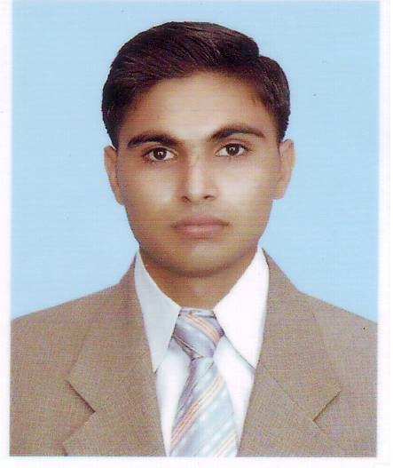 | Qamar  Civil Engineer
 | Phone Number | Whatsapp +971504753686 / +919979971283
 | E mail Address | Qamar.290372@2freemail.com
 | Date of birth | 21/04/1993
 | Nationality | Pakistani

Code of Professional Practice

Uncompromised honesty and dedication for the disbursement of my role as a professional engineer for the benefit of the employer, for the service to community and for self-development and well-being.

Objectives
To work on a challenging job profile which provides an opportunity to enhance my technical skills and knowledge. Now I’m seeking towards a job in a growing organization to avail knowledge by knowing the ability under the supervision of highly skilled staff and profession of highly command management.

Education

2012-2016 Shenyang Jianzhu University, Shenyang, Liaoning, China
B.S in Civil Engineering

2009-2012 G.C.T RASUL MB.Din (P.B.T.E Lahore)
D.A.E in civil

2008-2010 BISE Gujranwala, Pakistan
Matriculation

English
Language Skills

Speaking , listening ,writing and Reading.
Urdu

Speaking , listening ,writing and Reading.
Hindi

Speaking , listening
Chinese

Speaking , listening

Computer Skills

Auto CAD
Ms Office, Excel, PowerPoint
Operating System, Windows XP, Windows 7, Windows 8, Windows 10
E-Mail and Web Browsing
Self-Confident and Great Patience
Strong Inner Personal Communication Skill

Professional Experience
I have worked with Sea Blue Builders in the capacity of assistant Civil Engineer for four months (From 25/12/2015 to 25/04/2016).

Interests and Hobbies

- Playing Computer games
- Cricket, Football, Badminton, Billiards
- Learning Computer Softwares
- Reading Books
- Conducting Online research on Civil Engineering
- Swimming
- Reading diversified material on Religion & history

Reference

Reference will be provided upon request

