SALIM
SALIM.291044@2freemail.com 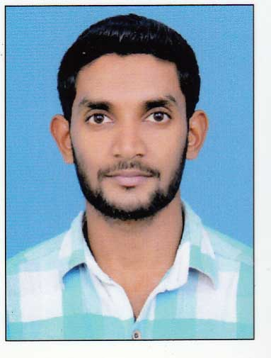

CAREER OBJECTIVE:

Seeking a challenging and rewarding position in system administration in a reputed organization where I can acquire new knowledge and sharpen my skills and put my efforts for achieving organizational as well as individual goals.
PROFESSIONAL EXPERIENCE:

Present Job:
Company Name : Akshaya e Center
Position : Reservation Executive
Date joined :11 Nov 2013
TECHNICAL SKILLS:

- MS Office
- Tally
- Installing and configuring operating systems and connecting to active directory
- Trouble shooting IT Hardware related problems
- In-house IT training to company staff
- Installing and Configuring the peripherals, software and drivers.
- Installing Configuring and Administering Network Topologies.
EDUCATIONAL QUALIFICATIONS:

- 2014: B.com Finance 55% (Calicut University)
- 2009: 12th, Science Govt Kerala, 60 %.
- 2006: 10th, GOV Kerala, 60%
PROFESSIONAL QUALIFICATIONS:
- 2009: Course Completion in Diploma Fire & Safety. (National Safety council of India)

OTHER SKILLS:

- Social media (For business and personal)
- Able to work efficiently within a team as a team player.
- Good communication skill to complete the task.
- Positive attitude, determined, high energies.
- Hard working, and sincere.
- Good decision making and analytical skills.
- Listening , driving

PERSONAL DETAILS:
Date of birth | : | 27/04/1990
Gender | : | Male
Nationality | : | Indian
Languages Known | : | English, Malayalam, Hindi, Tamil and Arabic.

DECLARATION:

I hereby declare that the above information is true and correct to the best of my knowledge.

