H a i t h a m
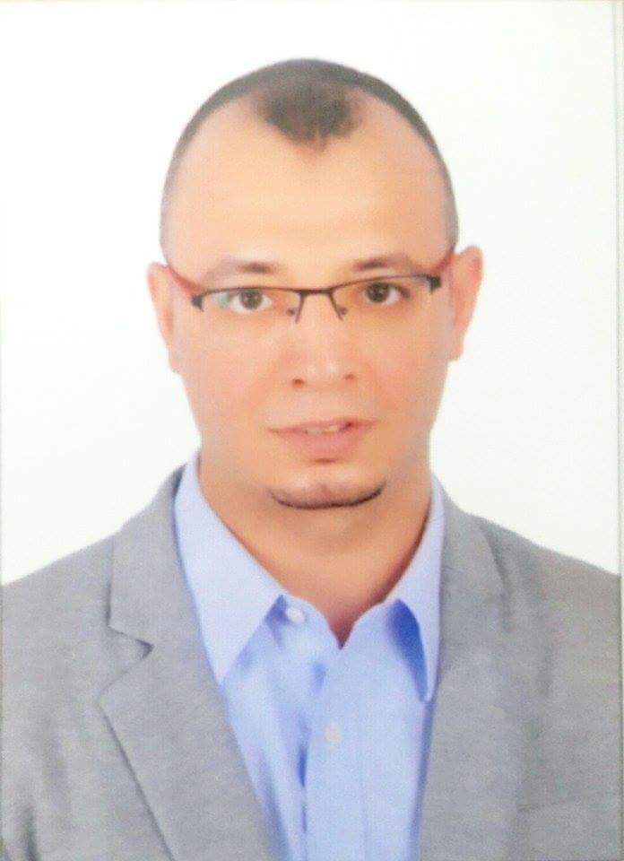

Mobile: C/o 0504973598
E-mail: haitham.291056@2freemail.com

O B J E C T I V E
To pursue a career suits and develops my skills, qualification and practical experience.

Experience

• Regional Financial Controller / Financial Manager: BDL GULF FZCo.
Business Activity: IT Distributer for (DELL – ASUS – Samsung – MSI – Acer –HCL - MCAFEE - …)
Job Title: Regional Financial Controller.
Based in: Dubai, UAE, from 01-June-2009 till Sep-2015.
Range: Head Office in UAE, Inter Companies in Kuwait, Qatar, Oman, Bahrain and Jordan.
www.bdlgroup.com

Work Duties

- As a financial controller / Financial Manager , I work directly with the CFO.
- Manage all financial tasks; oversee budgeting and accounting, Costing system for purchases inside
UAE and for Branches outside UAE.
- Preparing Monthly Profit and Loss Statement, and Preparing Quarterly Balance Sheet.
- Implement, and ensure compliance with internal financial and accounting policies and procedures.
- A.P. Settlements through bank finance to Suppliers (DELL – ASUS – MSI – Acer –HCL -MCAFEE)
- Management accounting; budgeting, financial strategy, analysis of Financial Reports using Ratios.
- Preparing Financial Budget for the Next Fiscal Year as per short term and long term Objectives, and as per other Budgets received from Sales and purchasing departments.
- Monitoring Budget achievement and Variance Analysis, and report positive and negative variances and
reasons of variances.
- Risk Analysis and financial solutions on business strategy.
- Feasibility Study.
- Monitoring and Reporting Aging Stock, and cooperate with concerned departments to determine expecting provision and required support from Vendor.
- Cash Flow Management.
- Monitoring with Credit Controller any delay from customers settlements, which may confuse Cash
Flow.
- Co-ordinate with legal department for required and supporting documents for any legal case.
- Internal Audit on Inter companies outside UAE.
- Prepare all supporting information for the annual audit.
- Negotiations and opening relationship with Banks for facilities.
- Prepare and report the plans about maximum using of banks facilities, to match between business opportunities, resources, cash flow, P&L and effect of bank finance charges on profitability, to achieve the maximum utilization and minimize cost.

• Chef accountant in Al-Hobail Medical Office
From 10/2006 To 30-04-2009 .
Riyadh, K.S.A.

Journal entry
Work Duties
(from working as an Accountant to Chef Accountant)

- All banking transactions related to trade finance like :
Issuing, amendment and cancellation of Letter of Guarantee (Initial, Final). Issuing, amendment and cancellation of Letter of Credit (credit, at sight). Settling of past due bills.
Issuing and settlement of Loans. Inward collections (CAD).
Renewing Bank Facilities.
- Imported purchases & Prepare cost of imported purchases.
- Expenses, beforehand expenses and overdue expenses.
- Final Adjustments including depreciation. Internal Auditing:
- Audit bank statement monthly.
- Audit Current Tenders.
- Follow up collections from Accounts Receivable and Tenders.
- Prepare and audit payroll.
- All payments for purchases, expenses, Assets and liabilities.
- Issuing of invoices.
- Controlling inventory.
Reports, financial statements and Adjustments:
- Supply information to management.
- Calculating sales turn over.
- Supply all Banking information related to Accounting.
- Prepare fixed assets depreciation statements and its journal entry.
- Prepare Ledger.
- Prepare trial balance and its adjustments.
- Income statement and Balance sheet.
- Cash flow statement.
- Feasibility study.

O T H E R E X P E R I E N C E S I N E G Y P T :
• Financial Accountant in Badr Al-Madina com.
From 3/2006 to 9/2006
• Financial Accountant in EL-Enany Pharm.
From 9/2003 to 2/2006
• Cost Accountant in Zenith com.
From 8/2002 to 3/2003
• Financial Accountant in Global Enterprise co.
From 6/2001 to 7/2002.
• Accountant trainee in Global Enterprise co.
From 7/1999 to 10/1999 & from7/2000 until 10/2000.
- Sales Person in Counter Trade Co.
From 7/1995 to 10/1995 ( Summer Activity).

S K I L L S

• Language
Arabic: Mother tongue.

English: Good in Reading, writing and spoken.

• Computer

Familiar with PCS.

Extensive experience in Microsoft Word, Excel, PowerPoint and Accounting programs.

E D U C A T I O N
• Bachelor of Accounting, 2001, Faculty of Commerce & Business Administration, Helwan University, with Grade Good.

• CMA : Part 1

P E R S O N A L I N F O R M A T I O N :

Nationality: Egyptian.

Place of Birth: Cairo, Egypt. Date of birth: 01/02/1979. Marital status: Married. Military service: Finished

