RADIOGRAPHIC TECHNOLOGIST

CURRICULUM VITAE

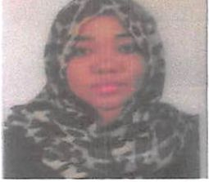

Islam

HAAD Licensing No :

AGT115667

Email: Nationality: Date of Birth: Gender: Marital Status:

[Islam.291157@2freemail.com](mailto:Islam.291157@2freemail.com)

Sudanese

3-7-1993

Female

Single

**Objective**

An extremely dedicated and resourceful Radiographer with in-depth knowledge and skills learnt over several years in a hospital environment and private clinic. With an incredible eye for detail, a high degree of accuracy and an unshakeable determination has worked effectively within a highly professional team of experts

**Education Qualifications**

The National Ribat University , Faculty Of Radiology And Nuclear Medicine sciences

**Training & Courses**

Global Education Training & Human Resources Administration Center with the following courses :-

1. Introduction to physics in computed tomography image
2. Introduction to physics in magnetic resonance image
3. Computed tomographic technique
4. Magnetic resonance technique
5. Clinical practice to computed tomographic technique and magnetic resonance technique

**Professional Work Experience**

A- Ministry of Defence G.H.Q.S.P.A.F DEP Chief of joint staff G.A of medical services in radiology department at the following:-

1. Conventional X-Ray.
2. X-Ray.
3. Dental X-Ray.
4. Emergency X-Ray.
5. Mammography.

From 12-2014 up to 12-2015.

B- Ministry of Health, aitamauz center for emergency and truma in radiology department at the following :-

1. X-Ray Unit
2. CT Unit

From 1-2016 up to 2-2017

**Additional Information**

Fluent in English.

Fluent in Arabic (mother tongue).