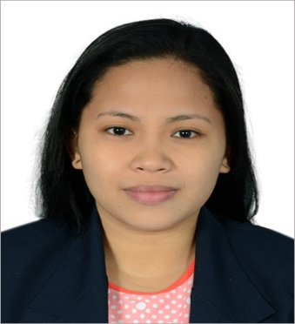
Nemvie
Email : nemvie.291423@2freemail.com

Objective:
Utilizing exceptional organizational and Communication skills
to make a positive contribution to the organization.
KEY Skills
Office Skills: | Answering Telephone & Front Desk Reception Customer Service Filing  Database & Records Management Strong Analytical Efficient in problem solving Hardworking Honest Efficient Persuading and negotiating ability Able to work with minimum supervision and under pressure Flexible to different types of work and settings Willing to be trained and work for long hours With fast typing ability
Professional Experience
Gaisano Grand (Philippines) Office Assistant,(Treasury Department) July 2013 to October 2015
Handle a variety of customer service and administrative tasks and resolve customer issues with expediency.
Answering Telephone calls.
Sorting Incoming and Outgoing Emails.
Replying / answering emails.
Filing, Editing, Scanning & Printing Documents

Hotel fortuna (Philippines) Receptionist June 2012- June 2013

- Attracts potential customers by answering product and service questions; suggesting information about other products and services.
- Responsible for ensuring customer satisfaction, resolving customer complaints and addressing any questions or comments those customers may have.
- Maintains customer records by updating account information.
- Maintains financial accounts by processing customer adjustments.

CERTIFICATES;
NCII Passer of Massage and Housekeeping
Eligibility (Encoder) 2009
Marketing and Hilton Philippines Seminars

educational Attainment

College: Bachelor of Science in Hospitality Management Major in Hotel and Restaurant Management Cebu

Technological University (2007-2012)

Secondary: Cansojong National High School (2003-2007)

Primary: San Roque Elementary School (1996-2003)

personal information

Date of Birth : June 29, 1991
Place of Birth : Talisay City, Cebu City, Philippines
Age : 24 years old
Civil Status : Single
Religion : Catholic
Citizenship : Filipino
Language Known : English,Tagalog & Cebuano

