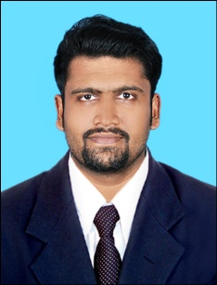
CURRICULAM VITAE
SICHIN
SICHIN.292235@2freemail.com

JOB OBJECTIVE
To obtain a challenging position in the service industry that utilize my education, skills and experience forwards the growth of the esteemed organization that can offer opportunities and challenges for professional growth and team spirit.
EDUCATIONAL QUALIFICATION
  - MBA HRM (Bharathiyar University) in 2015
  - B.A in English Literature (Calicut University) in 2013
  - PLUS TWO Commerce (National Institute of Open Schooling) in 2010
  - SSLC (CBSE) in 2008
PROFESSIONAL QUALIFICATION
- Diploma in Airline Management & Airport Ground Staff Training
In Calicut Institution-Kannur (An ISO 9001-2000 certified Institution)
- Diploma in Cabin Crew Management under Sted Council (An ISO 9001-2008 certified)
- CRS Training completed under journey's World, Ernakulam, Cochin (Galileo, Amedeus)
- Airport Training 1 month in Calicut International Airport.

COMPUTER SKILLS
- M.S. Office
- Tally
- Org. ERP. SAP
HOBBIES
- Net Surfing
- Playing soccer
- Listening Music

INTEREST
- Travelling especially Hill Station
- Driving
- Interact with different types of people

PROFESSIONAL STRENGTH
- Positive attitude and hard work
- Can work under pressure environment
- Quick adaptable to the change
- Possess a good communication and interpersonal skills

SKILL SETS
- Friendly nature
- Hard Working
- Honesty

LANGUAGES KNOWN
 | Read | Write | Speak
English
Malayalam
Hindi
Tamil | X | X
French | BASICS

DECLARATION
I do hereby declare that all the particulars furnished above are true to the best of my knowledge and belief.

