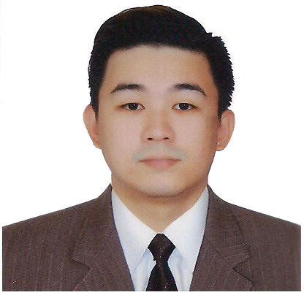
JONNATHAN
JONNATHAN.292980@2freemail.com

Objective

To enhance my knowledge and skills in the field of engineering and apply all the information I have learned and as well as improve my creativity for the innovation and benefit of the company.

Work Experience

Orange Coast Manila Inc. Position: Network Engineer

May 2013 – April 2016

Responsibilities:

Configuration, troubleshooting and installation of the following equipments:

- PBX Server / SIP Server (Yeastar MyPBX, 3CX)
- Network Firewall (Fortigate, Sonicwall)
- Routers and Switches.
- Different brands of IP Phones (Yealink, Fanvil, Grandstream)
- VoIP Gateways (FXO,FXS,GSM,E1)
- Designing network diagram of a VoIP system base on the client requirements.

- Access Points, Microwave Radios (Wireless Networks)

On-the-Job Training

Huawei Technologies Co., Ltd
Lipa City, Batangas, Philippines
December 5, 2012 – February 27, 2013

Responsibilities:
- Assist field engineers for the upgrade of the system (Globe Network)
- Delivery and installation of new equipments
- Changing of backup batteries of the equipments on the cell site
- Processing of the field engineers cell site working permit
- Planning and scheduling of the next day activities

Skills
Programming:

Visual Basic 6.0

Turbo C++

Assembly and Linux Language

Troubleshooting

PC Troubleshooting

Network Troubleshooting

Hardware analysis

Reformatting a PC, Laptop or Server

Software Applications:

Microsoft Offices

AutoCAD
Installations of different software applications

CISCO (course curriculum)

Educational Attainment
Tertiary | BACHELOR OF SCIENCE COMPUTER ENGINEERING
 | Lyceum of the Philippines University
 | Capitol Site, Batangas City, Philippines
 | 2006 – 2013
Secondary | Sta. Teresa College
 | Bauan, Batangas, Philippines
 | 2002-2006
Elementary | San Mariano, Elementary School
 | San Mariano, San Pascual, Batangas, Philippines
 | 1996-2002
Personal Information
Age | : | 26 years old
Birth Date | : | January 4, 1990
Birthplace | : | Batangas City
Gender | : | Male
Civil Status | : | Single
Citizenship | : | Filipino

I hereby certify that the above information is true and correct to the best of my knowledge and

belief.

