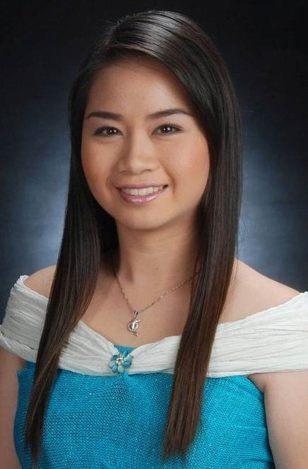 CANDY

OBJECTIVE:
Medical Technologist position with extensive clinical and laboratory experience in diagnosis and treatment of diseases.
To obtain a position that would best fit my professional qualifications and skills for continuous career improvement.

EDUCATION:
TERTIARY LEVEL
BACHELOR of science in medical technology | april 2010 | centro escolar university-manila
BAchelor of science in medical technology |march 2005 | manila centrAL UNIVERSITY-manila (1ST AND 2ND YEAR)
SECONDARY LEVEL
STO. NINO DE NOVALICHES SCHOOL| MARCH 2003| #36 BUENAMAR SUBD. NOVALICHES QUEZON CITY, PHILIPPINES
ELEMENTARY LEVEL
deparo elementary school| march 2009| deparo, caloocan city, philippines

SKILLS AND QUALIFICATIONS:
- Bachelors Degree in Medical Technology and Philippine Licensure board examination passer
- DHCC License Holder as Medical Laboratory Technologist: Valid until December 2016
- Basic Life Support Healthcare Provider: CPR and AED Program: Valid until: November 2018
- Quality Laboratory Technician since October 2014
- Internal Auditor of Medical Laboratories according to ISO 15189:2012
- Trainer/Super user in Phlebotomy
- Six years of performing laboratory services as Medical Technologist and excellent phlebotomy skills
- Experienced in operating equipment and chemicals used in specific tests.
- Performs CAP Proficiency Tests
- Profound ability to provide healthcare services in hematology, coagulation, blood banking, chemistry and other related services.
- Demonstrated ability to establish and maintain supportive relationships with patients, physicians, pathologists and co-workers.
- Experienced in laboratory's documentation
- Computer/Technology Savvy
Communication:
- I can work well with minimal supervision.
- Excellent communication skills and can provide quality health care services.
- Excellent problem solving skills especially in patient related issues.
- Fluent in English (Oral and Written)
awards , Leadership AND ACCREDITATION
- Joint Commission International Accredited (JCIA) Hospital| August 2015
- ISO 15189:2012 | October 2013
- College of American Pathologists (CAP) Laboratory | March 2015
- Phlebotomy in Charge/Trainer in Pre- Analytical phase, Phlebotomy : Dr. Sulaiman Al Habib Hospital| Dubai Healthcare City, UAE| December 2014
- Trained as DAC Internal Auditor for Medical Laboratories ISO 15189:2012 | May 2016
- Member- Philippine Association of Medical Technologists| Manila, Philippines| 2010- Present
- Assistant Chief Medical Technologist| Fairview General Hospital| Manila, Philippines| 2011-2012
- President- College of Medical Technology| Manila Central University |Manila, Philippines| 2003-2005
- Most Outstanding Student | Manila Central University| Manila, Philippines|2003-2005
- Consistent Class’ 1st honors (Elementary- Secondary Education)
- Graduated as Class Salutatorian| Deparo Elementary School| March 1999

WORKING EXPERIENCES
QUALITY- MEDICAL LABORATORY TECHNICIAN, PHLEBOTOMY IN CHARGE | HOSPITAL |dubai, uae | october 2013-present (END OF CONTRACT OCTOBER 2016)
appointed Phlebotomy in charge
- Supervises 5 Phlebotomists
- Training staff involved in the processes
- Draws blood from patients for analysis or other medical purposes: Assembles equipment, such as tourniquet, butterfly needles, disposable containers for needles, blood collection devices, gauze, cotton, and alcohol on work tray, according to requirements for specified tests or procedures.
- Verifies or records identity of patient and converses with patient to allay fear of procedure. Applies tourniquet to arm, locates accessible vein, swabs puncture area with antiseptic, and inserts needle into vein to draw blood into collection tube or bag. Withdraws needle, applies treatment to puncture site, and labels and stores blood container for subsequent processing.
- Performs finger and heel prick to draw blood.
- Performs blood culture collection: Direct and Indirect Method

QUALITY- MEDICAL LABORATORY TECHNOLOGIST
- Assistant of Total Quality and Laboratory Manager
- Helping in the development of processes,policies and procedures
- Deciding on the standards to be achieved
- Running checks (auditing) to ensure that work is being performed to those standards
- Identifying problems and making improvements
- Training staff involved in the processes

MEDICAL LABORATORY TECHNOLOGIST | FAIRVIEW GENERAL HOSPITAL| MANILA, PHILIPPINES| 2011-2013
- Performs routine specimen collection, hematological examination and microscopically of urine, stool, semen analysis
- Performs routine and complex blood chemistry, immunological and serological examination
- Performs Acid Fast Bacilli stain, Gram staining, KOH determination and performs routine culture and sensitivity including blood culture.
- Uses technical judgment to recognize unusual or abnormal finding and refer to the senior laboratory personnel.
- Performs Pre-employment and Annual Physical Examination

Candy
CV NO: 1759122
Click to send CV No & get contact details of candidate


