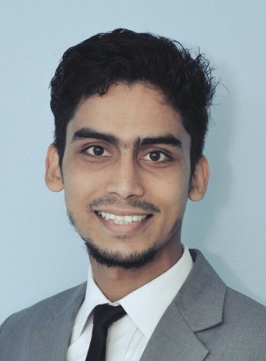
H A N E E F

HANEEF.293376@2freemail.com

OBJECTIVE

To build a career in a progressive work culture with the freedom to be innovative and creative and hence grow with the organization by contributing the level best.

Experience

2014 – Present |  | CUSTOMER CARE SUPERVISOR – ASSISTANT BILLING MANAGER  Lifeline hospital group is amongst the most highly respected healthcare organizations in the GCC countries with the vision of being the hospital of choice for the community by delivering best clinical care as well as customer service.  Department : OPERATIONS  Location : LIFELINE HOSPITAL, SOHAR- OMAN
Responsibilities  Abilities & Skills  2013-2014  Responsibilities |  | - To ensure the complete patient satisfaction by providing quality oriented service.  - Keeping and maintaining patient relationship.  - Oversee and streamline billing processes.  - Troubleshooting the billing and system errors.  - Plan and implement quality assurance for all processes.  - Special program/billing planning and implementation.  - Arranging Personnel development, Staff discussions and training/interviews, Team building for the front office department.  - Authorization and verification to edit the bills done by the billing team.  - Assist with the implementation of a new billing system.  - Proven ability to perform strategic planning and priority setting for the billing department  - Proven track record for improving process efficiencies and solving problems  - Strong leadership skills with an ability to motivate direct reports  - Excellent communication skills both written and verbal, and interpersonal skills  - Excellent analytical and problem solving skills  - Ability to manage multiple project concurrently  BILLING, CUSTOMER CARE ASSOCIATE -LIFELINE HOSPITAL  - Point of contact to the patients for all their hospital requirements to ensure the complete patient satisfaction.  - Acting as a connecting link to the patients with administration and operations.  - Coordinating the insurance patients with the respective departments for their treatment approvals & coverage’s.  - Registration and billing for patients using ‘Insta HMS’ software which is specially designed for the entire hospital management.
2011-2013 |  | MORTGAGE UNDERWRITER – PHH  One of the world’s largest independent BPO employing 30,000+ professionals across 40+ operation centers located in 14 countries. Global provider of business process and technology management services offering an integrated portfolio of analytics-driven back office and customer facing solutions that supports the entire customer lifecycle.  Process : UNDERWRITING  Location : SUTHERLAND GLOBAL SERVICES , COCHIN-INDIA
Responsibilities |  | - Authentication of loan applications, Loan pre-sanction documentation.  - Review, examine and underwrite loans to ensure soundness, business value and compliance with company and investor standards.  - Determine and document loan conditions and communicate requirements and/or decisions.  - Review detailed historical and projected financial analysis utilizing tax returns and financial Statements.  - Independently conduct full and compressive evaluations of a variety of complex, high- risk mortgage loan applications.  - Review and analyze special conditions, loan deficiencies and exception requests to determine appropriate course of action.  - Maintaining the current knowledge of market conditions and company lending guidelines.  - Evaluating debt ratio, loan-to-value ratios, credit score, property valuation and various other factors.  - Assigned responsibilities of approving and denying loan applications.  - Handling the tasks of generating complete underwriting of all mortgages.

ACHIEVEMENTS

- Awarded as the Best employee of Lifeline hospital in 2014 July.
- Had been recognized as the 2nd best employee of the process for the year 2012 from Sutherland Global services
- Achieved perfect attendance award from Sutherland Global services.
- Elected as the Arts secretary of the year 2009 in Sa Adiya College.

EDUCATION

2008 – 2011 |  | Graduation – BSc COMPUTER SCIENCE  Academy - Sa-adiya Arts and Science college, Kasaragod  (Affiliated to Kannur University, India)
LANGUAGE SKILLS |  | ENGLISH – Fluent  HINDI – Fluent  MALAYALAM – Mother tongue  ARABIC – Good
pERSONAL details  NATIONALITY Indian  DOB 11-09-1989  MARITAL STATUS MARRIED  HEIGHT 180cm  WEIGHT 67kg |  |  |  | PERSONAL strengths  Empathic & caring  Positive & Forward Attitude  Active & energetic  Dedicated & Committed  Creative & Innovative  Humorous & Youthful  Punctual & organized

