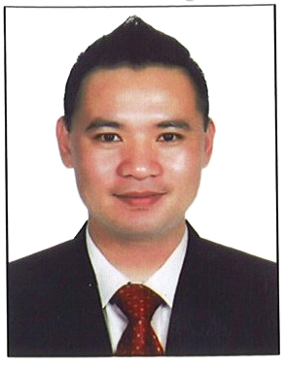
NICOLAS
NICOLAS.293583@2freemail.com
Position Applied: COMMIS CHEF HOT/COLD Section

CAREER OBJECTIVES
- Excellent communication skills with absolute politeness in verbal conversation.
- Believes in concept of ‘service with smile’
- Extremely pleasant personality with advent of good physique
- Able to contribute my skills and also acquire new skills that can be an advantage to the company I work for.

GULF EXPERIENCE:
PANOS RESTAURANT AND CAFÉ LLC
Dubai Investment Park 1
COMIS 1 / CONFECTIONER ASSISTANT
November 21, 2015 to Present.
Duties and Responsibilities:
- Central Kitchen Staff.
- Food preparation and presentation
- Preparing the Orders of two Branches Sahara and JLT.
- Assist in the production and preparation of mis - en- place in all the section of the kitchen and Sandwich Area.
- In charge in all expiration dates and (FIFO) First In First Out Items in the Walk In Chiller and Freezer, night shift duty
- In Charge in monitoring of Chiller and Freezer Temperatures.
- Receiving Delivery Stocks from a Supplier.

CHARLEY’S GRILLED SUBS AND RESTAURANT
Dubai International Airport Departure T1
Senior Cook/Cashier, Service Crew
January 2013 to November 15, 2015
Duties and Responsibilities:
- Duties involve daily store operation as a Cook, taking order, and assist customer service.
- Specialized in Cooking Sandwich.
- South west and Mediterranean Food.
- Cooking steamed rice and Salads.
- Cashiering.
- Doing paper works

CHARLEY’S GRILLED SUBS AND RESTAURANT
Deira City Centre Branch
Store In-Charge
Duties and Responsibilities:
- Paper Reports (BPW, DSR, Hourly sales records, Daily checklist etc.)
- Supervise and coordinate activities of assigned branch store which include merchandising, ordering, display, sales and inventory of the stores commodities and maintain daily reports and records relevant to store operations.

CHARLEY’S GRILLED SUBS AND RESTAURANT
Al Ghurair Branch Rigga Dubai
Team Leader (Franchise Opener staff)
Duties and Responsibilities:
- Pioneer batch of service crew employees who started the store operation.
- Training and supervised new franchise staff.

RECOGNATION RECEIVED
EMPLOYEE OF THE MONTH
Service Crew - Charley’s Grilled Subs
April and December 2013

EDUCATIONAL BACKGROUND
Certificate in Automotive Mechanic/Driving NC 11
Zamboanga Peninsula School – September 2012
Zamboanga City Phlippines

SPECIAL SKILLS
- Cooking, Driving, Computer literate

