­­­

**Diana**

**Email add.:** [**Diana.293844@2freemail.com**](mailto:Diana.293844@2freemail.com)

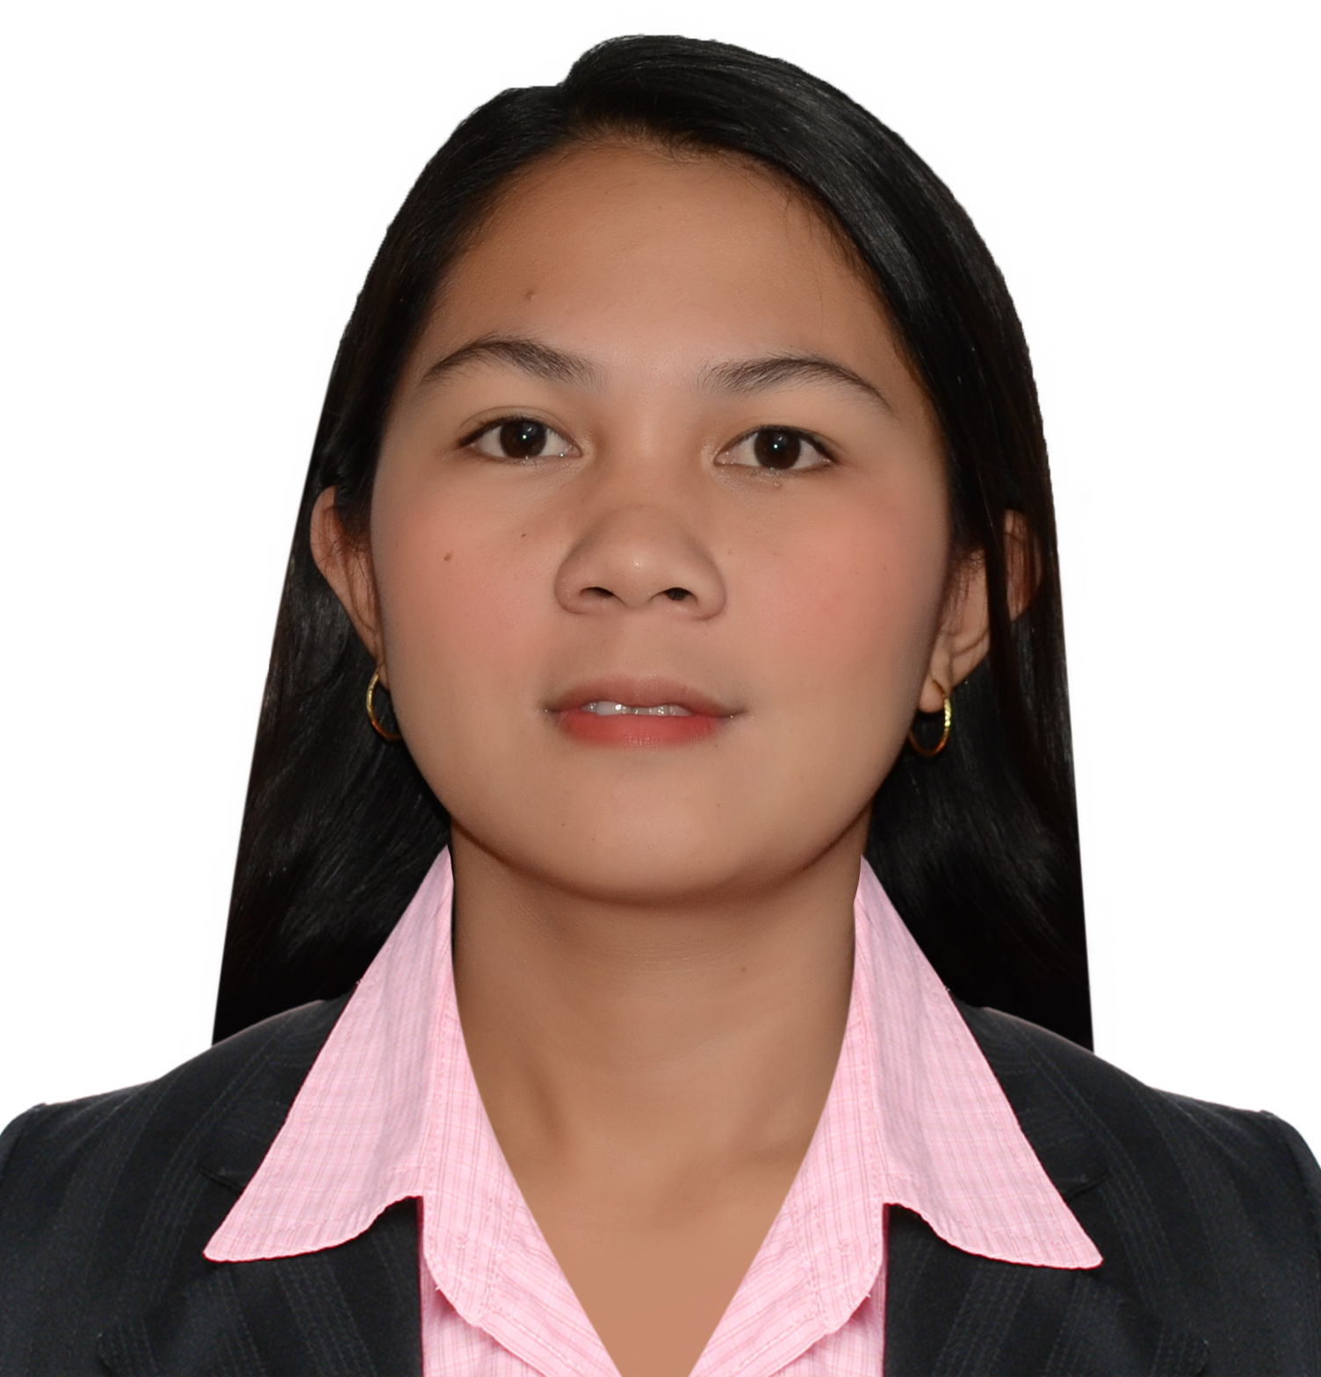

**Personal Information:**

Gender: Female

Civil Status: Married

Religion: Catholic

Nationality: Filipino

Birth date: April 16, 1989

Age: 27 y/o

**Achievement:**

GraduateMay 2012

Bachelor of Science in Civil Engineering

**Qualification:**

* Eastern Samar State University(ESSU)

Borongan City

2005 – 2012

CIVIL ENGINEERING

* Alugan National School of Craftsmanship and Home industries (ANSCHI)

Alugan San Policarpo E. Samar

2001 – 2005

**Language Known:**

English &Tagalog



***Objective***

*To obtain a challenging position that will utilize my skills and experiences and which will also provide me with the opportunity for growth and advancement.*



***Employment record:***

* ***MILLENNIUM ERECTORS CORP.*** – Cost Engineer/Estimator

April 02, 2015 – Present

Duties:

* Identify and quantify cost factors, such as production time, materials, and labor expenses
* Evaluate a product’s cost-effectiveness or profitability
* ***V. ROQUE CORP. –*** *Project-In-Charge*/*Site Engineer*

Jan. 07, 2014 – March 30, 2015

Duties: Determines project schedule by studying project plan and specifications; calculating time requirements; sequencing project elements.

* ***SSI METAL CORP. –*** *Project-In-Charge*/*Site Engineer*

July 24, 2012 – Jan. 03, 2014

Duties: Maintains project schedule by monitoring project progress; coordinating activities; resolving problems. Attend to technical and job site meetings or job site coordination.

***Skills and Interest:***

* *Interest in the field of Cad Designs, Drawings, Surveying, andEstimating.*
* *Computer Literate.*
* *Knowledgeable in Microsoft Word, PowerPoint, Excel, Auto-Cad.*
* *Can work under pressure and willing to be trained*
* *Responsible and Cooperative*

***Affiliations:***

* *Member of Philippine Institute of Civil Engineers (PICE)*

*(Student Chapter)*

***Seminar attended:***

* ***Construction Safety and Health Awareness Seminar***

*Manhattan Plaza, Cubao Quezon City*

*I hereby certify that the above information is true and correct to the best of my knowledge and ability.*

DIANA

Applicant

DIANA Q. CALOS

Applicant