RESUME

VEERAPANDIYAN | 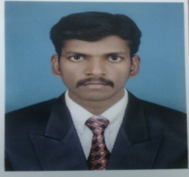
Veerapandiyan.294120@2freemail.com

Objective:

To become a professional in where my skills are strengthen and utilized for the execution of challenging opportunities in a reputed organization for its growth.

Educational Background:

Course | Name  of  the Institution | Board/ University | Year Of  Passing | Percentage
B.E  Instrumentation  &  Control  Engineering | A.V.C.College Of  Engineering  Mayiladuthurai | ANNA University,  Chennai. | 2015 | 6.5  (CGPA)
DIPLOMA  In  COMPUTER  SCIENCE | Don Bosco Polytechnic  College  Kazhiyappanallur. | DOTE Board | 2012 | 78
SSLC | T.G.N.M.Hr.Sec.School  Mayiladuthurai.  . | State Board | 2005 | 49
Work Experience:

- RMG Automation Chennai, “ROLE” R&D Engineer.

Area Of Interest:

- Production & Service
- Erection And Commission of Instruments
- Industrial Instrumentation
- Process Control
Core skills:
- Embedded System
- Lab View
- Ladder logic
- PLC, SCADA
- System Maintenance
Workshop attended:
- Attended the workshop on “MATLAB” in ” SRM UNIVERSITY ” Chennai .

Industrial Visit:
- Jayaram Bakery in Madurai.
Diploma Project:

- Net Watch

Engineering Project:

- Design of ZIGBEE controlled water level management system.

Personal Profile

Name : Veerapandiyan. S
Sex : Male
Marital Status : Single
Father’s Name : Subramaniyan.T
Languages : English, Tamil
Declaration:

I hereby declare that the information furnished above is true to the best of my knowledge.

Date:

