Personal data:
Curriculum Vitae | 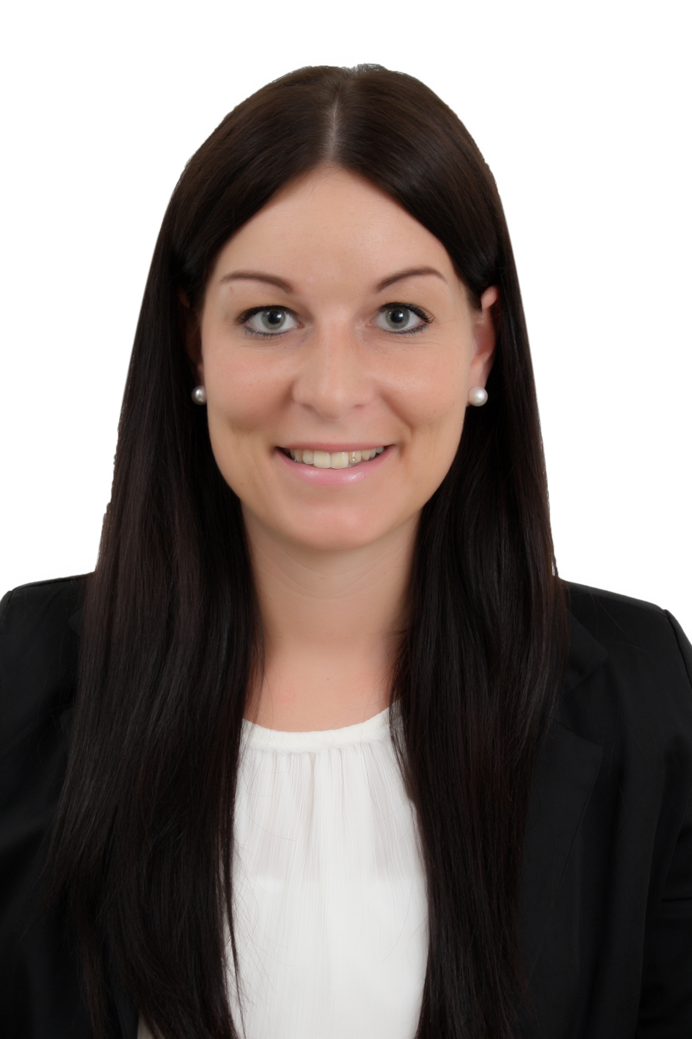

Name: Jacqueline
, Germany
Date of Birth: 14/07/1992
Nationality: German

Currently I’m on visit Visa in Dubai and available anytime for interviews

Education:
1998-2002 Grundschule Asch (primaryschool)
Asch
2002-2008Karl-Spohn-Realschule(highschool)
Gerhausen
2008-2011 Ferdinand von Steinbeis-Schule(practicalschool)
Ulm
Work Experience:
2011-2014 Ophthalmologist (medical assistant)
Dr. A. &M.vonEhr /Blaubeuren/Germany
2014-2015Surgery - Orthopedics (medical- operation
assistant)
Dr. A. Appel& Dr. P.Vogel / Laichingen/ Germany
2015-2016Company LEBOmed(sales & marketing)
Pharmacia Mehrstetten/ Germany
Additional Skill: Computer:  Languages:  Driving: | MS Office (Word, Power -Point, Excel, Outlook)  German, native language English  EU Driving license  hhjhhjjh

Jacqueline
CV NO: 1765116
Click to send CV No & get contact details of candidate


