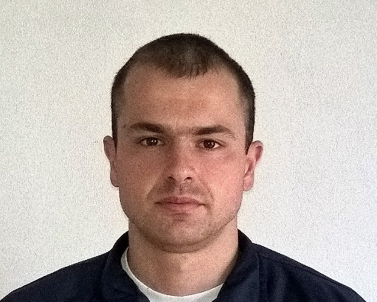
NAME: Marko
CELL PHONE: C/o 0503718643
E-MAIL: marko.294570@2freemail.com
DATE OF BIRTH: 27.08.1987.

EDUCATION AND TRAINING:
- School of Textile and Design, Leskovac, Srbija – Degree of a Designer of Textile.
- Faculty of Sport and Physical Education, Nis, Srbija, – Physical Education Teacher.
- Certified lifeguard pool.

WORK EXPERIENCE:
- Worked as a pool lifeguard at Sports Recreational Center „Dubocica“ (2008)
- Worked as a swimming coach at:
  - Swimming club „Nis 2005“ in Nis (2008-2010),
  - Swimming club „Health and Active“ in Nis (2012-2014),
  - Swimming club „Delfin“, a swimming club for children with special needs in Nis (2010).
- Worked as a fitness trainer for rugby clubs:
  - „Morava Geopardi“ in Leskovac (2012),
  - „Soko Vranje“ in Vranje (2013).
- Worked as a soccer coach for children at the soccer club „Veternica“ in Leskovac (2012).
- Founder of a Sports school for children „Zdravko“ in Leskovac (2014).
- Worked as a professional soldier (2014-2016), participated in flood rescue operations on Obrenovac and Tekija (2014), and was awarded for it, participated in the Military Parade „Korak Pobednika“ in Belgrade (2014) and Military Parade in Zrenjanin (2016).

OTHER USEFUL SKILLS:
- Fluent in English Language;
- Working knowledge of Greek and German Language;
- Basic knowledge of Microsoft Office programs:
  - Microsoft Excel - Microsoft Word
  - Microsoft PowerPoint - Microsoft Outlook

