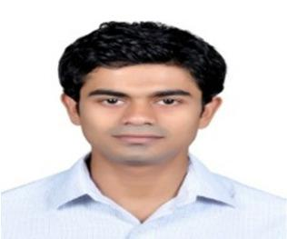
AMANULLA
AMANULLA.294668@2freemail.com

Technical Sales Engineer

A qualified Mechanical Engineer with 3+ years of proven expertise in Technical Sales, Proposals, Sourcing & Application of HVAC/R flow control devices, valves, pipes, fittings and related utilities, valves for water and waste water industry, waste management equipments. Aspiring for a challenging position where I shall apply my skills and better my experience and knowledge to positively attain the corporate goals.

Skills

Sales & Business Development

Negotiations

Proposals
and Costing

IT Abilities

Proficient in Technical sales, scheduling sales calls, regular client visits, preparation of technical & marketing documents for the HVAC/R valves, flow control devices, valves, pipes, fittings, water and waste water valves.

In depth study of project situations and market demands on technical and commercial ground to effectively negotiate and close deals with clients.
Pushing the limits to precisely and profitably prepare Technical and Commercial Bids, Pricing details and Cost Estimation for projects.
Wel l versed with MS Excel/MS Word/MS Powerpoint/ AutoCad/ CRM (vtiger) / ERP (Orion)

WorkHistory
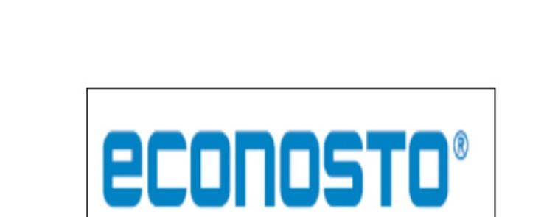
Technical Sales Engineer Aug 2015– Till now
Econosto Mideast B V Dubai, UAE

Respond to technical inquiries from electromechanical contractors or end users for HVAC/R flow control devices, valves, pipes, fittings and related utilities, valves for water and waste water industry.

Organize and schedule sales calls including regular client visits, consultant meetings etc.

Exploring potential new clients and opportunities. Maintaining good relationship with existing clients.

Coordinate with factory and business partners along with our support team on challenging enquiries and input data for product development so as to ensure the customer needs are met for future opportunities as well.

Project analysis and preparation of final technical and commercial bids in coordination with the support team.

Constant follow ups and negotiations with the client.

Carry forward the Sales functions of Enquiry Registration, Proposals, Order Entry, Negotiations, Meetings.

Coordination and follow up with respective factory for production status, completion and logistic related matters.

Keep track on payments and delivery on handled projects.

Taking up service related issues with the after-sales team and service personnel and imparting technical information to the distributors

Preparing sales reports including enquiry registration, invoicing, booking and stock prognosis.
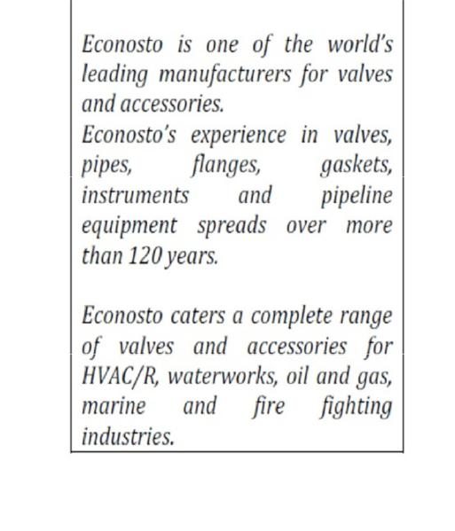

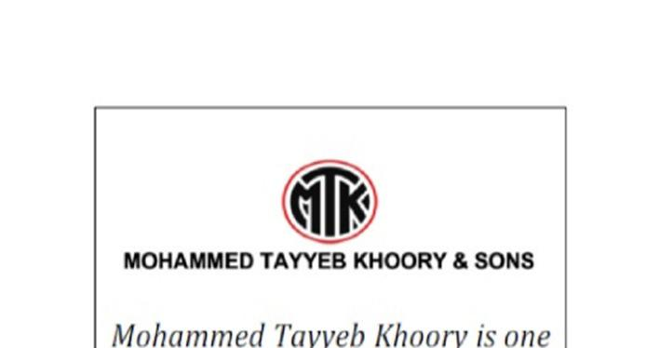  Project Sales Engineer | April 2013 - May 2015
Mohammed Tayyeb Khoory & Sons | Dubai, UAE

Handling the sales process such as enquiry registration, pricing, order processing, negotiation and maximization

Analysis of enquiries/tender documents, interact with appropriate sources to refine scope and concepts of enquiries/tender documents.

Prequalification of products/vendors with major clients, consultants and contractors.

Site survey, design, costing and preparation of Techno – commercial offer. Dedicated to achieve annual targets.

Execution of Waste Management Projects in hi rise buildings.

Determines project specifications by studying product design, customer requirements, and performance standards; completing technical studies; preparing cost estimates.

Prepares all technical submittals for the projects.

Coordinate and record meetings involving various departments of the company to discuss on the feasibility and possibilities of probable projects.

Follow up with customers on the tenders and quotations handled.
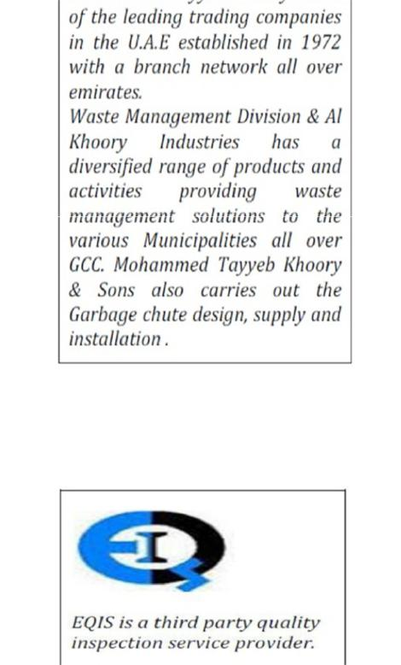

QC Engineer Trainee | Aug 2012 - Jan 2013
Engineering Quality Inspection Services | Chennai, India

Confirm the NDT technique selected for specified job. Interpret the results and qualify the job.

Quality surveillance, documentation, dimensional check and interpretation. Provide technical directions for specific task and assign work to

technicians or project sub groups.

Review or monitoring the approved quality or inspection plan.
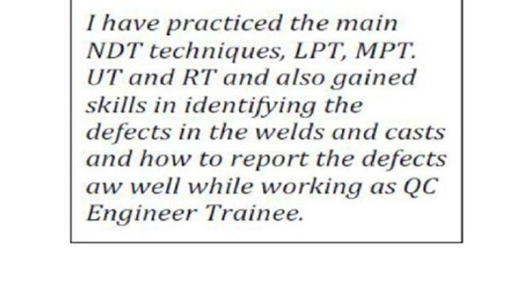

 |  | Education
 | 2008-2012 | 2005-2007
 | Degree in Mechanical Engineering (B.Tech) | 12th Grade (Secondary Education)
 | With first class from | With first class from
 | Government Engineering College, Thrissur | M.E.S Central School, Kuttippuram, Kerala
 | Affiliated to Calicut University, India. | Affiliated TO CBSE, India

Industrial Training & Exposure

 | Product Training in HVAC valves and flow control | Industrial visits at:
 | devices at the Econosto Mideast Head Quarters at Dubai | o | ONGC Plant Mangaluru
 | Training in Welding inspections by NDT techniques at | o | Iron Ore Factory ,Kuderamukh, Karnataka
 | Engineering Quality Inspection Services, India. | o | HMT, Kalamassery, Kerala.

Training in ISO procedures and operations at Mohammed Tayyeb Khoory & Sons , Dubai

