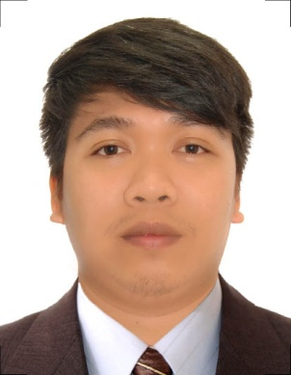
Gene
Gene.294742@2freemail.com

CAREER OBJECTIVE
To obtain any job position in an institution, where I can make the most of my education and training, over and above my interpersonal skill, as well as to acquire more knowledge and experiences and develop a positive, productive and lasting relationship with my employee and colleagues.
STRENGTHS
A hardworking, honest and trustworthy individual with skilled communication that create positive environment. Accomplish assigned tasks on time, and always willing to learn. Reliable and works well with others.
QUALIFICATIONS
Certified CAD Operator with expertise in completing the required work. Proficient in developing and implementing the work that may help the technical staff.Strong customer, interpersonal and organizational skills. Have the ability to administer, reprioritize, and deal effectively with multiple task. Strong ability to follow direction given by supervisor.

SKILLS
Profound knowledge of Auto Cad 2007 and MS Office. Developing drawings, maps to plan, developing reports and plans for construction sites and preparing sectional elevation maps. Ensured quality work to meet organization’s expectations. Ensured quality standards are met while drafting and implementing new and redesigned specifications. Ability to work independently and under pressure. Proficient in performing stupendously in team environment.

WORKING EXPERIENCE SUMMARY

January 2011 – January 2012
SM Department Store
Batangas City, Philippines
Sales Attendant

DUTIES & RESPONSIBILITIES:

• Assists/advice customers to find product selection they are looking for.
• Worked as a team member to provide the highest level of service to customers.
• Demonstrated that customers come first by serving them with a sense of urgency.
• Detail-oriented, efficient and organized professional.
• Confident, hardworking, a good team worker and have the ability to effectively manage time.

February 2012 – May 2013
R.S. Developer Co., Inc
Marikina City, Metro Manila
AutoCad Operator at OSP Engineering Department
Civil Works and Fiber Optic Cable Network

June 2013 – June 2016
Office of the City Engineer
Batangas City
AutoCad Operator at Planning Department
Sewage Works Engineering and Stormwater Drainage Technology

ON-THE-JOB TRAINING/AFFILIATION

Planning Department Office of the City Engineer, Batangas City

EDUCATIONAL ATTAINMENT

Tertiary Certificate in Drafting Cad
University of Batangas
Hilltop Batangas City
October 2007 – November 2010

CHARACTER REFERENCES

(References are available upon request.)

I do hereby certify that the above information is true and correct to the best of my knowledge and belief.

