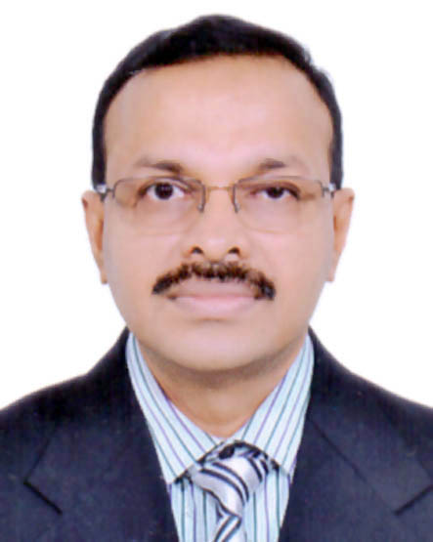
Vinod Vinod.294868@2freemail.com
IT MANAGER / IT HEAD
Expertise in executing full life-cycle projects; ramping-up projects within time, budget & quality parameters, as per project management & best practice guidelines in 24 years.

Profile Summary

A seasoned professional with 24 years of commendable success in:
~ Project Management ~ IT Operations ~ Delivery Management
~ Infrastructure Management ~ Datacenter Operations ~ Resource Management
~ Security Management ~ Network Management ~ Business Continuity Planning
~ Client Engagement ~ System Administrations ~ Process Management
- Expertise in analysis, design, implementation and management of enterprise-wide IT infrastructures
- Collaborated with the Senior Management and provided strategic direction on technology initiatives in line with the core organizational goals and business & profit objectives of the company
- Resourceful big picture thinker who confidently champions business objectives through technical leadership and business acumen, vendor negotiations and cost saving initiatives
- Excels in developing & motivating highly focused teams that successfully exceed company objectives
- Possesses broad competence in strategic management; distinction of driving new IT initiatives, designing corporate infrastructures& contributing in achievement of organizational objectives
- Excellent communication, interpersonal and problem-solving skills with ability to work in multi-cultural environment

Career Timeline
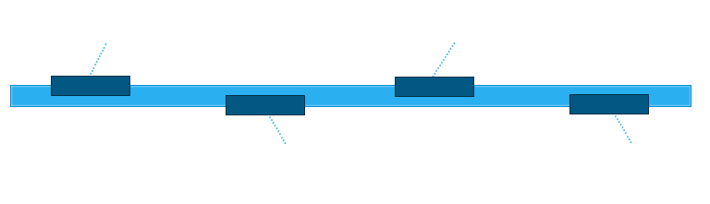
2014- 2017
1995-2005
2005-2014
1991-1995
Universal Group of Institutions- India
IT Executive
Khansaheb - UAE
IT Manager

Lavajet & BATCO UAE ICT Manager

Falcon Chemicals- UAE
IT Administrator
Core Competencies

- Handling the planning and analysis of entire IT operations along with establishing of short / long-term budgets for the preparation of IT blueprint for the organization
- Architecting support process for complex multiple technology multi product business solution by authoring business and technical SOPs; handling performance tuning, backup and recovery, space management, user management
- Designing & executing Datacenter consolidation, migration, and virtualization and move Business critical Applications
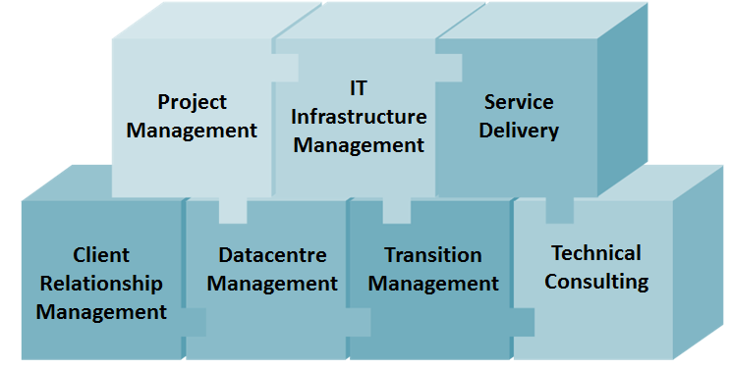
- Mapping client’s requirements & architecting customized solutions to suit their requirements
- Implementing monitoring systems at datacenters for clients & designing dashboards for critical components
- Managing the installation of servers, printers, drivers, various software, front end tools, etc.
- Assisting in design and implementation of network troubleshooting server network problems & conflicts
- Furnishing support in areas of computer hardware, network infrastructure and network security
- Suggesting improvements in the operations and processes to make the system full proof
- Rendering technical support / training to clients and site engineers for resolving critical technical issues
- Identifying performances bottlenecks and taking adequate measures to rectify the faults

Organizational Experience

Since Nov ’14 with A group of Companies ( Lavajet & BATCO), UAE as ICT Manager

Key Result Areas:
- Spearheading team of DBA's, Developers, System Administrators & IT Support Engineers; leading a major business transformation
- Co-coordinating the project teams & evaluation of each project stages
- Management of Fully integrated Cloud based Waste Management Application
- Strengthening the IT infrastructure through to implementing new technologies
- Accomplishes financial objectives by forecasting requirements; preparing an annual budget; scheduling expenditures; analyzing variances; initiating corrective action
- Maintains organization's effectiveness and efficiency by defining, delivering, and supporting strategic plans for implementing information technologies
- Preserves assets by implementing disaster recovery and back-up procedures and information security and control structures
- Entrusted with the responsibility of managing:
- Team of about 12+ IT Professionals from DBA, Application development, Infrastructure, Network & Security disciplines
- IT Backup & Business Continuity Planning (BCP)
- The implementation of the infrastructure strategy and set direction for continuous improvement
- Recruitment and training of new staff.
- Vendors management
- Rendering services as:
- Group IT Manager & Group General Manger as the IT Steering Committee providing advice on developments
- Project Head for the SAP ERP Implementation, Exchange Server migration from 2007 to 2010, PABX installation, server Virtualization (Hyper-V)

Significant Contributions:
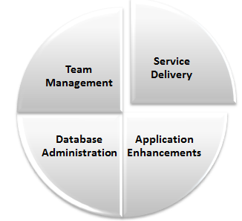
- Maintains quality service by establishing and enforcing organization standards
- Recommends information technology strategies, policies, and procedures by evaluating organization outcomes; identifying problems; evaluating trends; anticipating requirements
- New ICT procedures implemented,
- Verifies application results by conducting system audits of technologies implemented
- Support and Report Generation of the SAP Business 1
- Spearheaded the Administration of Email Server, Web server & Website
- Completes projects by coordinating resources and timetables with user departments and data center
- Migration of all standalone servers.to Hyper-V virtual environment as well as installation, configuration and maintenance of Hyper-V virtual server

Sep’05 with Khansaheb -Major Construction Company, Dubai as IT Manager

Key Result Areas:
- Spearheading team of DBA's, System Administrators & IT Support Engineers
- Entrusted with the responsibility of managing:
- Team of about 10+ IT Professionals from DBA, Infrastructure, Network & Security disciplines
- IT functions and activities in the company through the development of IT Strategies, Objectives and Policies
- Implementation of IT systems in order to ensure the provision of reliable, secure, high performance, cost effective IT services
- Mobile & fixed line telecoms including company-wide upgrades; Management of all Helpdesk activities and Service improvement efforts
- Development, review & certification of all back-up and Disaster Recovery Procedures & Plans. Management of all IT Backup & Business Continuity Planning (BCP)
- Rendering services as:
- Group IT Manager & Group General Manger as the IT Steering Committee providing advice on developments
- Project Head for the Exchange server 2007 installation, Exchange Server migration from 2007 to 2010, Migration to cloud exchange (office 356 E3) hybrid mode, VLAN configuration, PABX installation, server Virtualization (Hyper-V)

Significant Contributions:
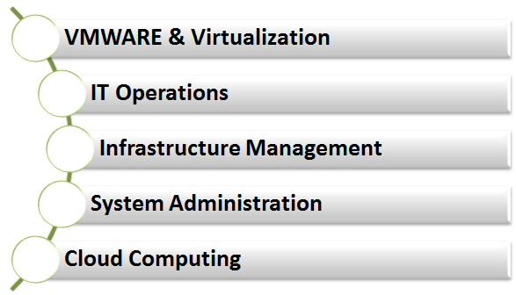
- Became the lead “go-to” person for:
- Delivery of cost-effective IT service & target 99.9% systems availability with agreed SLA's
- Implementation of IT Strategy in line with corporate strategy and supporting 1000+ IT users across 40 different location
- Migration of all standalone servers.to Hyper-V virtual environment as well as installation, configuration and maintenance of Hyper-V virtual server
- User support for the ERP –Mentor (Oracle)
- Management of office 365 cloud ( SharePoint, Lync, Exchange)
- Maintaining the availability, reliability and functionality of IT Systems through proactive monitoring of System Availability, Response times, Packet Loss, CPU Utilisation, Memory Utilisation, Disk Utilisation, Windows Service Monitoring, Event Log Rules

Feb’96-Sep’05 with Falcon Chemicals, Dubai as IT Administrator

Key Result Areas:
- Shouldered the responsibility of handling Database administration, User Support and Report Generation of the ERP system ORION in Oracle Consisting of modules:
- Finance (General Ledger, Accounts Receivable, Accounts Payable etc)
- Purchase Management
- Inventory Management
- Sales Management
- Production Management
- Fixed Assets Management
- Oversaw the preparation of management reports and report writing with Report Designer (Developer 2000), Microsoft Access and Crystal Report
- Spearheaded the Administration of Email Server, Web server & Website
- Customization and development of Add-on programs for the ERP Suite with Developer 2000, Visual Basic and Microsoft Access

Significant Contributions:
- Essayed a stellar role in the:
- Network administration of Novell NetWare, Windows 2000, Windows 2003 and Mail Network
- Management of Sophos Anti-Virus
- Completed total system development life cycle for the new ERP system.
- Execution of the design and development of the local area network for the new factory
- User support for the ERP (ORION & Tetra)

Career Commencement

Apr’91-Oct’95 with Universal Group of Institutions, India as IT Executive

IT Skills

- Network & Systems Security
- MS windows server 2003/2008/2012
- Active directory
- IT project management
- ERP- MENTOR, ORION, TETRA, SAP
- Backup – Backup EXEC
- Install configure and maintain Virtual environment (Microsoft Hyper-V)
- Management Antivirus (TrendMicro, Fsecure, Sophos)
- Exchange 2007/2010/ cloud 2013 ( Hybrid Mode)
- Microsoft Office 365, SharePoint & Lync
- VPN – SonicWALL
- Network Design, Implementation & Administration
- Black Berry Enterprise 10
- Broad understanding of current communication technologies and protocols
- Networking: TCP/IP, IPX/SPX, and Ethernet
- IP PABX (Alcatel, LG & Cisco)
- Disaster Recovery Planning & Risk Assessment

Academic Details

- Master of Science (Physics, Electronics and Computer Science), 1991, University of Kerala, India with Distinction (Third Rank)
- Post Graduate Diploma in Computer Applications, (1994), Directorate of Technical Education, Kerala, India
- Bachelor of Science (Physics), 1989, Gandhiji University, Kerala, India

Personal Details

Languages Known : English, Hindi, Malayalam & Tamil
Marital Status : Married, with two children
Date of Birth : 26 May 1969
Nationality : Indian
Driving License : Valid UAE Driving License

(Refer to Annexure for Major Projects)

ANNEXURE

Major Projects

Exchange 2016 Cloud Installation (Hybrid Mode)
Organization : Lavajet Company & BATCO (January 2017)
Duration : 2 Months

SAP Upgrade
Organization : Lavajet Company & BATCO (August 2016)
Duration : 3 Months

Fully integrated Cloud Waste Management Application
Organization : Lavajet Company & BATCO (July 2016)
Duration : 8 Months

Exchange 2013 Cloud Installation (Hybrid Mode)
Organization : Khansaheb (July 2014)
Duration : 4 Months

PABX installation (Siemens- 5 Installations in Remote Locations)
Organization : Khansaheb (January 2014)
Duration : 6 months

Hyper Virtualization (Converting Physical to Virtual Environment)
Organization : Khansaheb (March 2013)
Duration : 6 months

VLAN Configuration
Organization : Khansaheb (April 2013)
Duration : 2 Months

Upgrade of ERP Mentor
Organization : Khansaheb (May 2013)
Duration : 5 Months

Exchange Server Migration from 2007 to 2010 (1150 Mail boxes)
Organization : Khansaheb (July 2013)
Duration : 6 Months

New Data center
Organization : Khansaheb (July 2008)
Duration : 3 Months

PABX installation (Alcatel – Migration to IP PABX)
Organization : Khansaheb (June 2007)
Duration : 4 Months

Exchange Server 2007 Installation (450 mail boxes)
Organization : Khansaheb (January 2007)
Duration : 3 Months

ERP (OION) Installation - Migration from TETRA to ORION (DB : Oracle)
Organization : Falcon Chemicals (April 2002)
Duration : 7 Months

PABX Installation (Alcatel)
Organization : Falcon Chemicals (May 2001)
Duration : 3 Months

ERP (TETRA) Installation
Organization : Falcon Chemicals (January 1996)
Duration : 6 months

