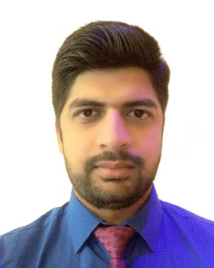
Sulaiman
Sulaiman.294877@2freemail.com

Career Objective

Seeking a position where I can optimally utilize my knowledge & skills in realizing organization’s strategic aims while developing a successful career personally.

Education

- University of Bahrain 2010-2015 B.Sc. in Electrical Engineering
CGPA = 3.32
Major GPA = 3.52

- Pakistan Urdu School, Bahrain 2008-2010
Pre-Medical, Higher School Certificate (HSSC)

- Pakistan Urdu School, Bahrain 2006-2008
Science, Secondary School Certificate (SSC)

Work Experience

Earth-enerji Environmental Services (Current Employer)
Department: Sales and Marketing
Position : Sales Engineer

Thyssenkrupp Elevators Almoayyed (13th June – 31st Oct 2016)
Department: New Installation Sales
Project : Full Time Internship

Gulf House Engineering (5th July 2015 - 31st Aug 2015)
Department: Electrical Design
Project : Full Time Internship

Al Saad Power Projects (1st July 2014 - 31st Aug 2014)
Department: Operations Department
Project : Full Time Internship

Skills
Computer Skills:
MS Office (Word, Excel, Power Point)
MATLAB.
AutoCAD
Solidworks

Interpersonal Skills:
Quick learner, confident, able to work under pressure; excellent team player and self-motivated.

Languages:
English, Urdu and little Arabic.

Workshops Attended:

- 2016 - RICI - EnMS Seminar on ISO
50001:2011

- 2015 - Viva - Career Hunters Program

- 2015 - E-government - Data Collection Survey

- 2014 - IET Symposium - Student Organizer

- 2014 - Bahrain Society of Engineers - Cyber Security

- 2013 - Batelco - Negotiation Essentials Course
(E- Learning)

- 2013 - Graduation Project - Endurance Enhancement of Battery Charger by Solar panel

- 2009 - Bahrain Garden Club - Garden Photography (3rd prize)

Interests
Billiards / Fishing

Personal Information

Date of Birth: 26th-August-1991
Nationality: Pakistani
Place of Birth: Bahrain
Driving license: Available

