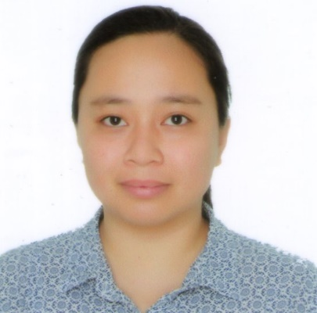

Arch. Evenly
Evenly.295278@2freemail.com
____
Education Attainment

*Architecture Licensure Examination – Board Passer last January 2016

*Bachelor of Science in Architecture
University of San Carlos, Talamban, Cebu City, Philippines, -graduated on October 2014

*Secondary Education
Iloilo Central Commercial High School, Iloilo City, Iloilo, Philippines, -graduated on March 2008

*Elementary Education
Iloilo Central Commercial High School, Iloilo City, Iloilo, Philippines, -graduated on March 2004

Skills Summary
Design expertise -developed through studies and demonstrated as apprentice in several firm

- Proven eye for detail in documentation - from design development through to construction
- Flair for both schematic and concept design
- 3D visualization
- Design presentations
- Understands construction methods and detailing
- Knowledgeable with building estimates
- Acquire basic knowledge on Electrical, Mechanical, Fire Protection, Electronics and Plumbing
- Experience in producing planning and presentation drawings utilizing sketch up, V-ray, Lumion, Photoshop, Revit, Autocad

Technical

- Proficient in AutoCad, ProgeCad, Sketch-up V-ray, Lumion, Photoshop, Revit
- Operating systems:Windows XP, Vista, 7, and 8; Microsoft Office: MS Word, MS Excel, MS Powerpoint;

Experience:

Home Base: Home base Architect
1st St. Juntado Subd. Calumpang Molo, Iloilo City
(July 2015 –Present)
Position: Architectural Revit/Cad Operator
- Designing Houses, Renovations and Institutes. Exterior & Interior.
- Revit User
- Do conceptual design output in Autocad/Sketch-up.
- Do 3d presentational output with Sketchup V-ray, and Photoshop.
- Work with Draftee (Australia Base) & Homeplanningsw (UK Base)

Company Name: Que International Design
Arsenal St. Iloilo City, Iloilo
(December 2014 –June 2015)
Position: Cad Operator
- Designing Institutes/ Interior.
- Producing detailed working drawings with the use of Autocad/Sketch-up.
- Do 3d presentational output with Sketchup V-ray, and Photoshop.

Company Name: Infrastructure Development Office
University of San Carlos Talamban Campus, Nasipit, Talamban, Cebu City, Cebu, Philippines
(June, 2014 – October, 2014)
Position: Apprentice
- Designing Institutes.
- Producing detailed working drawings with the use of Autocad.
- Do presentational output with Lumion, Sketch-up, V-ray, and Photoshop.
- Do building estimates.
- Conduct site inspection/supervision

Company Name: ED+A Firm
Capitol Site, Cebu City, Cebu, Philippines
(March, 2013 – December, 2013)
Position: Apprentice
- Designing different type of building such as: Residential, Resort and Commercial.
- Producing detailed working drawings with the use of Autocad, Progeecad.
- Do presentational output with Lumion, Sketch-up, V-ray and Photoshop
- Do building estimates.
- Conduct site inspection/supervision
- Processing of Paper Works

Personal Data

Age : 25 Date of Birth: September 26, 1991
Gender : Female Civil Status : Single
Height : 5’1/2” Weight : 69.5kgs.
Nationality: Filipino Language : English, Tagalog, Cebuano, Ilonggo
More about me
- Youth Leader of AJNC CEBU & ILOILO
- Choir Member of AJNC
- Owner of Luna’s Arrozcaldohan (Iloilo), and Paling Merchandising
- Singing/Playing Piano/Composing Songs
- God Fearing Person

