Curriculum Vitae
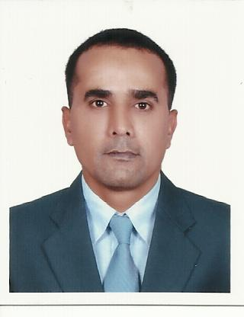

ABDULRAHIM
ABDULRAHIM.295496@2freemail.com

PROFESSIONAL SUMMARY
Hard-working, multi-tasking Executive Assistant with outstanding telephone, scheduling and documentation skills. Detail-oriented and driven Executive Assistant with expertise in problem solving and managing daily office functions.
SKILLS
• Excellent communication skills • Professional phone etiquette

• Fluent in Arabic, English, Hindi, & Marathi. • Computer proficient
• Human resource laws knowledge • Knowledge of cdp portal (adm)

• Team building • Knowledge of Local Laws of MOL & MOI

• Self-motivated • Energetic personality

• Sports enthusiast • Works well under pressure

WORK HISTORY

EMPLOYER: - BANIYAS LAND GENERAL CONTRACTING LLC

LOCATION: - BANIYAS ABU DHABI (UAE)

JOB TITLE: - PUBLIC RELATION OFFICER (Human Recourse)

START DATE: - AUGUST 2010 (still working here)

- Ensure proper documentation for new employees for Medical & Emirates ID processing up to submitting to PRO for Visa Processing & Stamping & Labour Card. Monitoring the visa cancellation and coordination up to repatriation. Well versed in labour law - trade licenses, visas, labour issues, and an expert in Administration.

- Keep eye on more than 75 shops, Including LLC, Establishments, Cafeterias, Restaurants, supermarket. More than 300 Employees.

- Obtained building and specialty permits from local jurisdictional agencies, (MUNICIPALITY, ADDC, ETISALAT)

- Worked with construction administration consultants to plan field observations on Schedule.
- Oversaw the entire building turnover process, while enhancing communication between all construction management.
EMPLOYER: - ADITYA BIRLA MINAX (IDEA CELULLER INDIA PVT. LTD)

LOCATION: - AURANGABAD (MAHARASHTRA) INDIA

JOB TITLE: - CUSTOMER SUPPORT EXCUTIVE (CSE)

START DATE: - FEB 2010

END DATE: - JULY 2010

- Answered a constant flow of customer calls.

- Addressed and resolved customer product complaints empathetically and professionally.

- Managed customer calls effectively and efficiently in a complex, fast-paced and challenging call center environment.

EDUCATION
BACHOLER PROGRAM IN BUSINESS ADMINISTRATION (BPBA) IN 2010
Specialization IN HUMAN RESOURCE MANAGEMENT
PUBLIC RELATION MANGMENT
FROM: - NAITIONAL INSTITUE OF MANAGEMENT (NIM)
MUMBAI (MAHARASHTRA) INDIA
Computer Skills: MOL WEBSITE, MUNICIPALTY WEBSITE, MS OFFICE, OUTLOOK, SOCIAL NETWORK
PERSONAL DETAILS

DATE OF BIRTH: - 16/05/1980
NATIONALITY: - INDIA
MARTIAL STATUS: - MARRIED
PLACE OF ISSUE: - ABU DHABI

