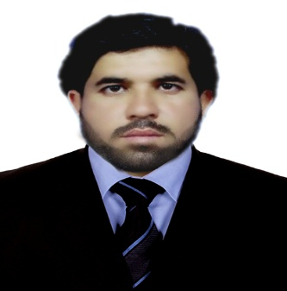

MUHAMMAD

MUHAMMAD.295663@2freemail.com

OBJECTIVES
To join an organization where I can grow on the basis of my personal abilities and to provide effective and efficient service to the best of my knowledge & expereince. To work devotedly in dynamic environmnet to fullfill the organization and personal goal.

ACADEMIC QUALIFICATION

EXAM | YEAR | BOARD / UNIVERSITY
B.E (Mechanical Engineering) | 2013 | Sarhad University Peshawar, Pakistan
HSSC- Pre-Engineering | 2009 | BISE Peshawar
S.S.C- Science | 2007 | BISE Peshawar

Working as Mechanical (MEP/HVAC) Site Engineer.

Company Name: Al Yash A/C Installation Works LLc, Sharjah- UAE
Duration: From 10 January 2016 To Still Working
Project: Sheikh Mohammad Bin Rashid al Makhtoom City, Dubai-UAE

Company Name: Ghulam Farooq Group of Companies Karachi, Pakistan
Duration: From January 2015 To December 2015
Project: Shaukat Khanum Memorial Cancer Hospital, Peshawar- Pakistan

Responsibilities:

- Good working experience on Installation, Maintenance and Operations.
- Installations of Vapor Compression system, Cooling towers, Pumps, AHUs, FCUs,
Reheat Coil, VAV, VCD, Ducts and Pipes.
- Prepare detailed design report & Selection of suitable HVAC systems.
- Maintain and perform repair on all HVAC equipment’s
- Co-ordination of Mechanical Plumbing & Firefighting system.
- Supervision of operational equipment’s involved in plant firefighting and plumbing system.
- Supervising all compressors & pumps from installation to commissioning and further operating and maintenance.
- Marking for HVAC system, fire alarm system and firefighting system etc. from approved drawing.
- Reviewing heat load calculations, air quantity, duct sizing & pipe sizing of HVAC Systems.
- Calculating of square feet of installed ducts and pipes for final bill
- Handling the Project Team
- Understanding and working on drawing of HVAC system, firefighting and fire alarm
- Ability to handle multiple projects & deadlines with management skill.

Worked as Maintenance Engineer in MIA Corporation Pvt Ltd. Peshawar- Pakistan.

Responsibilities:

- Operating of Vapor absorption system, Cooling towers, Pumps, AHUs, FCUs and energy meters through BMS system.
- Preparing daily energy saving report through Building Management System (BMS).
- Writing professional progress reports for operation & maintenance of HVAC system.
- Supervising predictive, preventive and corrective maintenance.
- Organizing routine maintenance & servicing schedules.
- Improving the design, performance and efficiency of existing HVAC system.
Troubleshooting/repairing of HVAC/BMS components (Controllers, Actuators, VAV’s, VFD’s etc

Languages:

- English Urdu & Pushto

Persnol and computer Skills:

- Good presentation skills
- Good communication
- Problem solving skills with ease
- Social moballization skills
- Good supervision
- Excellent knowledge about Auto CAD, Pro E, MS Office & HAP

DECLARATION:

Being technically sound, young and enthusiastic I am confident that I can fulfill your esteemed organization’s requirements. I wish and hope that I’ll get the privilege of serving your organization.

