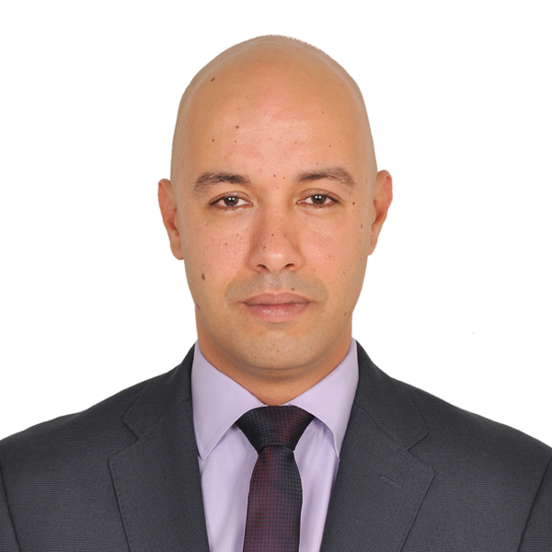

Yasser

Yasser.295697@2freemail.com

Experienced pharmacy management professional wishing to contribute expertise in a leadership role in a retail pharmacy chain or healthcare environment. Skilled in successful customer service, marketing, business development, and stock control. Proven ability in introducing medications to big government hospitals and increasing sales. Fluent in Arabic (native tongue) and English languages.

- Pharmacy Management  - Strategic Planning & Thinking  - Budgeting & Financial Management | - Sales Coaching & Training  - Team Supervision  - Relationship Building | - Decision Making  - Sales Management  - Customer Service

Professional Experience

LANCASTER PHARMACIES (PART OF PIONEER VISION GROUP)
GENERAL MANAGER MAY2017-PRESENT
General management professional with with experience in strategic planning, improving operational efficiency, team building and project management. Able to quickly understand complex concepts, indentify and solve problems, turn ideas into logical strategies, and implement systems that optimize productivity, decrease vacancy rates and increase bottom line.
- Leadership and People Management - attract, motivate, coach and develop team members.
- Financial Management - budget, forecast, review financial statements and manage business metrics.
- Communication - communicate, project voice, speak with senior management and present.
- Business Management - understand strategy, decision-making, work flow and vital business function.
- manage successful projects, risks, costs and project teams.

PLANET LLC, Abu Dhabi, UAE 2012 – 2017
Pharmacy Manager
Develop business and maintained margin while promoting sales. Manage and train pharmacy support staff. Serve as Pharmacist in Charge, supervising medicine preparation. Oversee ordering and safe storage of medical products. Represent pharmacy in professional manner at all times.
- Budget and handle financial management tasks.
- Dispense prescription medicines to the public.
- Ensure compatibility of different treatments.
- Check dosages and ensure medicines are correct and safely supplied and labeled.
- Maintain register of controlled drugs for legal and stock control purposes.
- Sell over-the-counter medications.
- Counsel and advise public on treatment of minor ailments.
- Advise patients of any adverse side-effects of medicines or potential interactions with other medications
and treatments.
- Arrange delivery of prescription medications to patients.
- Remain knowledgeable and updated on pharmacy practices.
- Strengthen business relationships and work with other personnel in order to maximize business potential.

ITTIHAD, Abu Dhabi, UAE 2011 – 2012
Pharmacy Manager
Managed stock levels and made key decisions about stock control. Created solutions to tackle competitor activity. Ensured all staff treated customers in polite manner and exceeded customer expectations. Interacted with customers on regular basis to gain feedback on quality and service effectiveness. Generated sales on daily basis. Handled account budgets, expenditure forecasts, and P&L accounts.
- Oversaw Al Ittihad Pharmacy, opening business and arranging orders to hotels for their clinics. Ordered medicine and negotiated with purchase manager for supplying alternatives. Wrote quotations and resolved problems as they arose.

HEALTH FIRST, AL WATHBA CLINIC, Abu Dhabi, UAE 2009 – 2010
Pharmacy Manager (2009 – 2010)
Oversaw team of four pharmacists and two assistants, leading development of sales activities. Ensured companies and customer goals were aligned and met.
- Promoted to manage Al Wathba Pharmacy, rearranging pharmacy to expose high profit expensive product to customers and utilizing benefits of large window of pharmacy; resulted in doubling of sales. Utilized color stickers on high-profit products to assist pharmacist in choosing high-profit medicine effortlessly, which helped in increased profits. Arranged staff schedules to successfully balance work and personal lives; motivated staff and ensured healthy competitive spirit with acknowledgement of best seller. Worked toward excellent customer service , coaching and training staff on selling points.

Pharmacist (2007 – 2009)
Developed business and maintained margin while promoting sales. Managed and trained pharmacy support staff. Served as Pharmacist in Charge, supervising medicine preparation. Oversaw ordering and safe storage of medical products. Represented pharmacy in professional manner at all times.
- Handled budgeting and financial management tasks.
- Dispensed prescription medicines to the public.
- Ensured compatibility of different treatments.
- Checked dosage and ensured medicines were correct and safely supplied and labeled.
- Maintained register of controlled drugs for legal and stock control purposes.
- Sold over-the-counter medications.
- Counseled and advised public on treatment of minor ailments.
- Advised patients of any adverse side-effects of medicines or potential interactions with other medications
and treatments.
- Arranged delivery of prescription medications to patients.
- Remained knowledgeable and updated on pharmacy practices.
- Strengthened business relationships and worked with other personnel in order to maximize
business potential.

AMMAN PHARMACEUTICAL INDUSTRY (A.P.I), Cairo, Egypt 2005 – 2006
Medical Sales Representative
Contributed to the first sales team responsible for developing and managing business relationships with customers and famous doctors to inform them of the company and promote API products (positioning campaign). Competed with two of the biggest ophthalmic pharmaceutical companies in Egypt, building a good reputation and successfully introducing medicine inside some of the biggest governmental hospitals.
- Consulted on and dispensed medications and dealt with insurance matters.
- Created, maintained, and increased sales within designated territory by favorably influencing prescribing habits of the targeted customers.
- Demonstrated thorough knowledge of pharmaceutical products and competitor products to further educate physicians and healthcare providers.
- Arranged and provided continuing education and services to targeted physicians and pharmacists.
- Developed and delivered informative sales presentations based on individual customer needs to maximize market share of designated product portfolio.
- Received feedback about products, reported to supervisor, and attended regular meeting to discuss progress.

Education & Credentials

Master’s in Business Administration, UNIVERSITY OF WOLVERHAMPTON, UK, Expected Completion in 2018
Bachelor’s in Pharmacy, Cairo University, Cairo, Egypt, 2004

Certifications & Licensures
Advanced Pharmacy Management, Lead Zone Training Center, UAE, 2014
Strategic Thinking and Planning, Spearhead Training Center, UAE, 2011
Supervisory Management, Spearhead Training Center, UAE, 2010
Selling Skills Course, Scope Training Center, Egypt, 2006
Marketing, Russian Institution Training Center
HAAD License (Can be transferred to DHA)
UAE Driving License

Technical Skills
Windows
Office Tools
Microsoft Word and Excel

