MUFEEDHA  Mufeedha.296160@2freemail.com  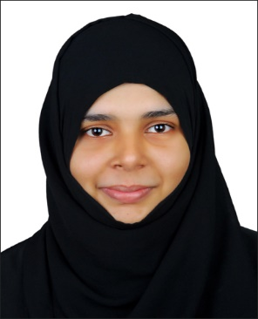  Nationality  Indian  Date of Birth  18/02/1993  23  Place of Birth  Kerala, India  Marital Status  Married  Visa Status  On Husband visa  References  Available on Request | Objective
 | An experienced kindergarten teacher looking for an opportunity with a well-known organization where I can use my knowledge and skills for the development of students and good reputation of firm.
Work Experience

EMERGING BUDS SCHOOL, Chammanur, Kerala India
Kindergarten Teacher ( ALDI curriculum ) 2015 June to 2016 March
Responsible for improving student achievement through rigorous assessment, curriculum development, and instruction.

Duties:

- Working with youngsters in an early childhood setting.
- Maintaining the daily rhythm of the Kindergarten.
- Supervising school children in the playground and on walks outside the school
- Being alert to situations that require immediate attention and then responding appropriately.
- Creating effective and engaging lesson plans.
- Managing the day to day running of the classroom.
- Updating pupil records on a daily basis.
- Attending all related staff, school and community based meetings.
- Preparing morning snacks for school children.
- Administering first aid and medical attention to children who havebeen hurt.

Key Skills and Competencies

- Willingness to go above and beyond the call of duty to ensure that all pupils achieve
- Using speech and body movement to communicate with a class.
- Positive attitude towards children.
- Establishing good relationships with parents and with other staff members.
- Committed to maintaining and improving own personal competence.
- Committed to eliminating any discriminatory practices towards pupils based on race, origin, gender, socio-economic status, disability, religion, or political beliefs.

 | Academic Qualification:
- Pursuing MBA under SIKKIM MANIPAL UNIVERSITY

- BSc Mathematics from CALICUT UNIVERSITY ( 2011 – 2014 )

- Higher Secondary from ICA EHSS (2011)

- Senior Secondary from Rahmath EHSS (2009)

“I hereby certify that the above information are true and correct to the best of my knowledge and belief”.
Mufeedha

