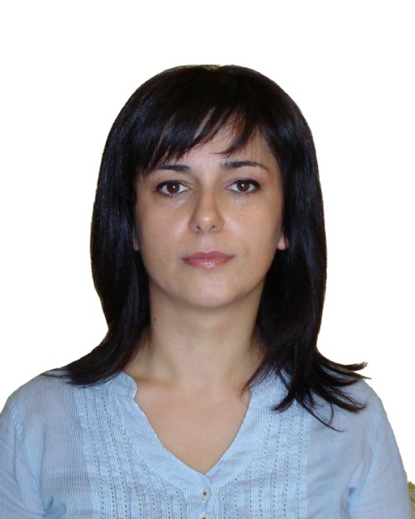
Curriculum vitae
GENTJANA GENTJANA.296695@2freemail.com

BIRTHDAY
25 October 1981
mARITAL STATUS
Married
CITIZENSHIP
Albanian

work experience
May 2015 – August 2016 Dubai , UAE
- SENIOR ARCHITECT at “Tulipa Landscaping LLC“ company, part of “ARJ Holding LLC“.
(Tulipa Landscaping LLC is a build & design company, which includes all the landscape works: softscape, hardscape, lighting and irrigation system).
Job dscription:
Senior Architect in Design, of Landscape but not limeted , (hardscape, softscape, landscape lighting, swimming pools , Gardens and Rest Areas , Water features). My work includes 3d visualization, Shop drawings , etc.

June 2008 – August 2014 “Kodra e Diellit ” Villas Residence , Tirane , Albania
- SENIOR ARCHITECT in “Agikons LLC“ company .
(Build & Design company in construction of villas and buildings for busines , tourism and residential use).
Job dscription:
Senior Architect, starting from the design project of the residential villas, following the construction from the foundation process to finalized facade, giving solution step by step to the details, and the implementation on the infrastructure. Interior design also .

November 2007– May 2008 Kamez, Albania.
- Architect in Kamza Municipality, Tirana Region.
(Architect Design Leader in Urban Planning Department.)
Job dscription:
- Architect on Building Permissions Architect in Kamza Municipality.
- Team Leader in LAND ADMINISTRATION AND MANAGEMENT PROJECT , undertaken by The World Bank in association with MINISTRY OF PUBLIC WORKS, TRANSPORT AND COMMUNICATIONS. This job includes urban planning and updating existing urban plans.
Mach 2006 – November 2007 Tirane , Albania .
- Architect in “ ARPA Studio 05”.
(Architecturial Design Studio, including interior and exterior design.)
Job dscription:
Architecturial Design of residential buildings, restaurants and touristic buildings, commercial buildings, urban planning, interiors etc.
September 2005 – Februay 2006 Tirane, Albania .
- Architect in “ITAL PROJECT – Studio”.
(Architectural Consulting and Design Company, branch of Italian Consulting Company)
Job dscription:
Architecturial Design of residential buildings, restaurants and touristic buildings, commercial buildings, interiors etc.

April 2005 – September 2005 Tirane, Albania .
- Cad – Drafter in “Studio A”.
(Architecturial Design Studio, including interior and exterior design.)
Job dscription:
Architecturial Drafting of residential buildings, restaurants and touristic buildings, commercial buildings, interiors etc.

- Architect in “New Construction Enterprise”.
(Build & Design company)
Job dscription:
Architecturial Design of plans of residential buildings, in Sales Department.

November 2004 – September 2005 Tirane, Albania.
- Cad – Drafter in “Studio A”.
(Architecturial Design Studio, including interior and exterior design.)

- June 2004 - September 2004 Vlore, Albania
Cad – Drafter in a Design Studio.
(Architecturial Design Studio, including interior and exterior design.)
EDUCATION
1996 –2000 Hight School “Hallim Xhelo” Vlore, Albania

2001-2006 Polytechnic University of Tirana Tirana, Albania

- Bachelor in Architecture. ( 5 Years of studies )
FOREIGHN LANGUAGES
English (Very good level . Certified by “Qendre e Formimit Profesional” in Vlore , Albania.)
Italian (Very good level)
ComputER skills

AutoCAD, 2D & 3D (certified by “ADAS”).
Autodesk Architectural Desktop 2006
3D Max (certified by “ISSETI”).
Lumion
Twinmotion
Artlantis
Sketchup
Adobe Photoshop
Windows (related application: Word, EXCEL)

