Dear Sir / Madam,
This letter is to express my interest in working with your esteemed company as IT professional. I am a BCA graduate and at the moment pursuing M.Sc. IT. I have 4 years’ experience in IT sector in UAE.
You will find me to be well-spoken, energetic, confident, and personable type of person on whom you’re esteemed company will rely. Please see my resume below for additional information on my experience.

Thank you for your time and consideration

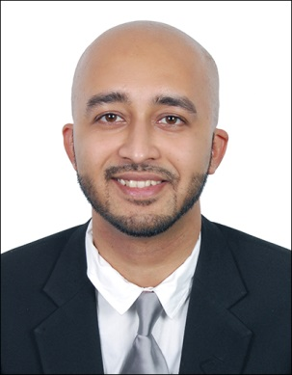

Dennis

Dennis.296930@2freemail.com

PROFILE

To make optimum utilization of my talent, skills, abilities and knowledge where I would be able to pursue a challenging career in an environment of growth-oriented and that offers me vast opportunities for reaching the frontiers in this field.

EDUCATIONAL QUALIFICATION

APRIL 2004 TO MARCH 2006 COMPLETED HIGHER SECONDARY FROM ABU DHABI INDIAN SCHOOL, ABU DHABI STUDIED ACCOUNTANCY & COMMERCE.
RESULT 65% (FIRST CLASS).

APRIL 1993 TO MARCH 2004 COMPLETED SECONDARY EDUCATION FROM ABU DHABI INDIAN SCHOOL, ABUDHABI. RESULT 75% (A GRADE).
APRIL 2006 TO MAY 2009 3 YEARS DEGREE COURSE (BACHELOR OF COMPUTER APPLICATION) 1 SUBJECT ACCOUNTING & FINANCIAL MANAGEMENT- Grade First)
At the moment I am pursuing M.Sc. IT degree (2 year course which will be completed by April 2016)
TECHNICAL EXPERTISE

Operating Systems: | Windows 2K/XP/Vista/Win 7/Win 8/Win 10
Microsoft Office | Office XP/2K3/2K7/2010/2016
Microsoft Outlook | 2003/2007/2010/2016
Antivirus Software | Norton/Symantec/Kaspersky
Programming Languages: | C, C++, VB, Java
Backup Devices | NAS
Servers | MS Server 2003, XMPP, Enterprise Anti-Virus
Other | Networking, VPN Routers

WORK EXPERIENCE

From June 2014 till today
Working with Alpha Data Services Dubai, deputed to Shell Petroleum International as On Site Technical Support.

From 2011 Feb till June 2014
Worked with Emirates National Establishment – Abu Dhabi (2 years contract) looked after the IT requirements of the main office and sister companies such as Emirates National – Stevedoring Division, Modern Kitchen Equipment Co and Elite Private School.
I was responsible for the following jobs:-
- All windows operating systems
- Exchange server 2003 & 2007
- Router & switch configuration
- Windows 2003 & 2008 active directory configuration
- DHCP
- DNS
- Data backup
- Antivirus administration
- VMware
- MS outlook
- Hardware troubleshooting
- Printer and scanner configuration
- Software installation and troubleshooting
- CCTV Configuration.

From 2009 – 2010 (2 years)
Worked Transgenez Company based in Bangalore and gained experience in Customer Service, Administration, HR, Accounts Assistant, Payroll Management as well as Call Centre Agent.

Also gained experience in installing software in PC’s. Printers, Laptops and solving virus problems.

DECLARATION

I hereby declare that the above information is correct to the best of my knowledge.

Looking forward to a successful meet in your esteemed Organization.

